**Report (Draft)**

Impact Modeling and Characterization of Spot Welds (Phase I)

To

Auto/Steel Partnership

by

Zhili Feng

Srdjan Simunovic

Oak Ridge National Laboratory

Oak Ridge, TN 37831

January 21, 2009

# Table of Contents

Table of Contents ii

Acknowledgment 1

1 Executive Summary 2

2 Introduction 2

2.1. Problem Statement 3

3 Objectives and Scope of Work 4

4 Literature Review 5

4.1. Global Joint Models 7

4.2. Local and Failure Models 8

4.3. Conclusions and Directions for Model Development 10

5 Materials, Welding and Testing 11

5.1. Materials and Testing Coupons 11

5.2. Welding 11

6 Microstructure Characterization 14

7 Impact and Static Test of Spot Welds 16

7.1. Experiment data analysis for spot weld model development 18

7.1.1 Effect of test equipment 22

7.1.2 Effect of failure mode 24

7.1.3 Loading mode and rate effects in mixed mode specimens 25

7.1.4 Deformation 27

7.1.5 Summary 31

8 Weld Microstructure and Property Modeling 31

8.1. Modeling Approach 32

8.1.1 Electrical-Thermal-Mechanical Interactions/Coupling 33

8.1.2 Thermal-Metallurgical-Mechanical Interactions/Coupling 33

8.1.3 Electric Contact Resistance 33

8.1.4 Modeling Microstructure Evolution 35

8.1.5 Incrementally Coupled Modeling Approach 36

8.2. Results 36

9 Development of SWE 39

9.1. Coupling of solid elements of the nugget with shell elements of the sheet metal 41

9.2. LS-DYNA implementation 42

9.3. Base material properties 43

9.4. Simulations 45

9.4.1 Lap Shear Simulations 45

9.4.2 Cross-Tension simulations 48

9.4.3 Mixed Mode simulations 51

10 Conclusions 55

11 Future Work (Phase II) 55

12 References 56

**LIST OF FIGURES**

Figure 1 Through-thickness shear distribution in shells in beam RSW model 3

Figure 2 Organization and relationship among various tasks in Phase I 5

Figure 3 Dimensions of lap-shear specimen (shear-mode) 12

Figure 4 Dimensions of cross-tension specimen (opening mode) 12

Figure 5 Mixed loading specimen (tensile + twist mode) 13

Figure 6 Weld nugget appearance of DP780 and DQSK welds. Solidification void was observed in DP780 welds. 15

Figure 7 Microhardness mapping of spot welds. Only upper half of the spot weld is measured. The line plots show the hardness variations alone the dashed lines in the hardness mappings. 15

Figure 8 Effect of weld size on the failure load of spot welds 17

Figure 9 Percentage change of failure load as function of loading rate (impact speed) 17

Figure 10 World Wide Web interface to the test data 19

Figure 11 Comparison of static and impact loading for cross-tension test. Material is DQSK steel with spot weld button size 4mm. 20

Figure 12 Piecewise linear fit (blue) to the impact test (red) 21

Figure 13 Lap-shear tests under different loading speeds. DP steel. Nugget diameter is 4.3 mm. 22

Figure 14 Cross-tension tests under different loading speeds. DP steel. Nugget diameter is 4.3 mm. 23

Figure 15 Lap shear tests with different failure modes. DP steel. Nugget diameter is 4.3 mm. 24

Figure 16 Mixed-mode tests, quasi-static loading. DP steel. Nugget diameter is 5.9 mm. 25

Figure 17 Mixed-mode tests, impact loading. DP steel. Nugget diameter is 5.9 mm. 26

Figure 18 Lap-shear tests deformation. DP steel. Nugget diameter is 5.9 mm. 27

Figure 19 Lap-shear tests deformation. DP steel. Nugget diameter is 4.3 mm. 28

Figure 20 Lap-shear tests force history for two different failure modes. DP steel. 28

Figure 21 Cross-tension test deformation for different speeds. DP steel. Nugget diameter is 4.3 mm. 29

Figure 22 Deformation for cross-tension test under quasi-static and impact loading. DP steel. Nugget diameter is 4.3 mm. 30

Figure 23 Total displacements for cross-tension test. DQSK steel. 30

Figure 24 Total displacements for cross-tension test. DP steel. 31

Figure 25 Resistance spot welding – a four-way coupled electrical-thermal-metallurgical-mechanical process 32

Figure 26 Steel-steel contact resistance-temperature-pressure diagram of DQSK steel. 34

Figure 27. Predicted weld nugget as represented by the peak temperature (top), volume fractions of different phases (middle), and microhardness distribution (bottom) in a DQSK spot weld. 37

Figure 28. Predicted weld nugget profile as represented by the peak temperature distribution (top), volume fractions of different phases (middle), and microhardness distribution (bottom) in a DP780 spot weld. 37

Figure 29. Comparison of microhardness distribution in a DQSK spot weld. Top: prediction, middle: microhardness measurement, bottom: line plot along the middle plan of the steel sheet. 38

Figure 30. Comparison of microhardness distribution in a DP780 spot weld. Top: prediction, middle: microhardness measurement, bottom: line along the middle plan of the steel sheet. 38

Figure 31 Configuration of the spot weld model in the through-thickness direction. Model 1 has shell elements in the HAZ and the plate whereas Model 2 used 8-node solid shell for the HAZ. The middle figure shows the coupling between the 4-node shell and solid. 40

Figure 32 Spot weld model scheme and its failure zones. 43

Figure 33 Test and its optimal piecewise fit (1% error tolerance) for DQSK material properties. Cross symbols denote points of linear segments. 44

Figure 34 Test and its optimal piecewise fit(1% error tolerance) for DP780 material properties. Cross symbols denote points of linear segments. 44

Figure 35 Zones in the spot weld model 45

Figure 36 Lap shear specimen model. Detailed FEM mesh 46

Figure 37 Lap shear test simulation for small spot weld nugget diameter (4.3 mm). DP780 steel. 46

Figure 38 Comparison of the resulting force for experiments and simulations for DP780 steel, small spot weld diameter (4.3 mm). 47

Figure 39 Lap shear test simulation for large spot weld diameter. 47

Figure 40 Comparison of the resulting force for experiments and simulations for DP780 steel, large spot weld diameter (5.9 mm). 48

Figure 41 Geometry configuration of the cross-tension specimen. Detailed FEM discretization. 49

Figure 42 Cross-tension specimen deformation before and after the joint failure. DP780 steel, large spot weld diameter (5.9 mm), coarse mesh. 49

Figure 43 Comparison of the force vs. displacement history from simulations and experiments. DP780 steel, large spot weld diameter (5.9 mm), coarse mesh. 50

Figure 44 Comparison of the model with experiments for quasi-static and impact tests. DP780 steel, large spot weld diameter (5.9 mm), coarse mesh. 50

Figure 45 Geometry configuration of the mixed mode specimen. Detailed FEM discretization. 51

Figure 46 Mixed mode 0 degree test. DP780 steel, spot weld diameter 5.9 mm 51

Figure 47 Force displacement data for mixed mode 0 degree test. DP780 steel, spot weld diameter 5.9 mm 52

Figure 48 Mixed mode 30 degree test. DP780 steel, spot weld diameter 5.9 mm 52

Figure 49 Force displacement data for mixed mode 30 degrees test. DP780 steel, spot weld diameter 5.9 mm 53

Figure 50 Mixed mode 90 degrees test. DP780 steel, spot weld diameter 5.9 mm 53

Figure 51 Force displacement data for mixed mode 90 degrees test. DP780 steel, spot weld diameter 5.9 mm 54

**LIST OF TABLES**

Table 1 Summary of welding conditions and weld nugget sizes 14

Table 2 Failure modes of spot welds in lap-shear and cross-section tests 16

# Acknowledgment

The authors acknowledge with gratitude the technical guidance of the Auto/Steel Partnership Strain Rate Characterization Project Team, especially of the technical contributions of the following members: Dr. Kathy Wang (Chair, General Motors), Dr. Dave Muelemen (past Chair, General Motors), Omar Faruque (Ford), Tau Tyan (Ford), J. Z. Cao (Chrysler), Ilaria Accorsi (Chrysler), (Chrysler), Ming Chen (U.S. Steel), Min Kuo (ArcelorMittal), Raj Mohan Iyengar (Severstal N.A.) and (Auto/Steel Partnership). Experimental data were provided by Dr. Y.J. (Bill) Chao and Y. Kim of University of South Carolina under a companion project sponsored by the Auto/Steel Partnership.

Research was sponsored by the U.S. Department of Energy, Assistant Secretary for Energy Efficiency and Renewable Energy, Office of Vehicle Technologies, as part of the Lightweight Materials Program, under contract DE-AC05-00OR22725 with UT-Battelle, LLC.

# Executive Summary

This report covers the Phase I Concept Feasibility development of a novel and robust spot weld modeling approach, supported by experimental data, for advanced crashworthiness computer aided engineering (CAE) of spot-welded auto-body structures, to promote efficient optimization of structures for light-weighting while meeting crash requirement and cost-effectiveness.

The Phase I developed the initial version of the Spot Weld Element (SWE) modeling framework and demonstrated the effectiveness of such modeling approach. The initial development phase cover two AHSS grades and one gauge thickness. The constitutive models used in the SWE incorporated the microstructure changes in the weld region of AHSS that were obtained using an integrated electrical-thermal-mechanical-microstructural resistance spot welding model and validated by weld microstructure characterization. Failure criterion properly dealing with the failure mode changes during impact of AHSS spot weld is being formulated based on the experimental data and fracture mechanics principles.

Future phases of the project are planned to cover wider range of materials, thickness ranges, various welding/joining issues, and further refinement/improvement of the SWE approach for efficiency and accuracy.

# Introduction

A primary premise that drives increased use of advanced high-strength steels (AHSS) in auto body structures is the drastic improvement in performance while reducing the weight. Resistance spot welding (RSW) is by far the most common joining process used in automotive manufacturing. Typically, there are thousands of spot welds in a vehicle. Because the separation of spot welds can affect the crash response of a welded structural component [1], the static and dynamic behavior of the spot welds has been one of the critically important considerations in vehicle design and manufacturing.

RSW of AHSS presents unique technical challenges for automotive structure applications. Due to their high carbon and alloying element contents, AHSS are considerably more sensitive to the thermal cycle of welding than the conventional steels used in auto body structures. The higher grade AHSS (e.g. DP800/1000, TRIP, boron) are more difficult to weld and more susceptible to forming brittle microstructures and solidification-induced defects in the weld region. In addition, heat affected zone (HAZ) softening can occur. Therefore, RSW of AHSS can exhibit very different structural performance characteristics than the ones made of conventional steels [2-7]. AHSS RSW generally has higher load-bearing capacity, but can fail under different failure modes (button pullout, interfacial, or mixed). The structural performance of AHSS RSW [8-12] is highly dependent on the grades and types of AHSS [2, 6, 13]. There can be considerable variations in microstructure and properties in the weld region for a given type and grade AHSS made by different steel producers, due to the differences in steel chemistry and processing routes employed [3, 5]. Furthermore, impact experiments [9, 10, 12] on joints and structural components (top hat and double hat sections) have shown that RSW have different responses under static and dynamic loads.

## Problem Statement

In recent years, computer aided engineering (CAE) based simulation of behavior of auto body structures during crash has become an indispensable tool that enables rapid and cost-effective design and engineering of crash resistance auto body structures. Spot welds in FEM crash impact simulations are usually modeled with two sub-models; a kinematics model of the joint and the associated constitutive model describing the material-related response of the joint. The kinematics of the joint describes the distribution of the deformation in the spotweld region and it must conform to the global response of the two or more connecting plates. Currently, the kinematics of the joint is primarily modeled as point-to-point connection by means of flexible or rigid (i.e. constraints) line finite elements. The line connection limits the constitutive spot weld models to extrinsic properties, force and moment-based laws. One of the principal problems with line-based kinematics models in AHSS spot welds is that the stress and strain distributions in the weld area are not accurately represented. For RSW in *conventional* steel structures, the dominant failure mode is the button pullout and the inadequate calculation of the shear stress may not be a major concern in impact simulation of vehicles. However, for AHSS RSW, accurate determination of the shear stress may be critical because of the reported interfacial failure or mixed interfacial plus pull-out failure mode. In addition, the multiple failure modes and the changes in failure modes under different loading conditions require development of more versatile failure criteria based on the fracture and damage mechanics principles than the resultant force-based ones. From the structural stiffness perspective, the bar and beam models typically yield acceptable accuracy under tension, out-of-plane torsion and bending loads. For in-plane torsion and shear, the stiffness values are inaccurate. The brittle fracture associated with the interfacial failure of the spot weld is more likely during impact where plastic deformation of the base material may be constrained by large elastic stress field. Compared to a gradual increase in hardness in the heat-affected zone in mild steel RSWs, the AHSS exhibit sharp hardness change that adds to brittleness and notch sensitivity of the joint.

A simple illustration of beam element drawback is the distribution of through-thickness shear in the shear-lap joint model where nodes of two plates are joined via a beam. The shell element theory requires stresses to vanish on the shell surface and, therefore, the resulting stress/strain distributions in the weld area are not accurate. Situation is illustrated in Figure 1.

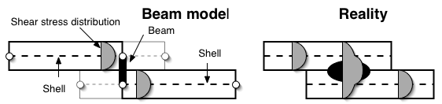

Figure Through-thickness shear distribution in shells in beam RSW model

This drawback can be alleviated by more elaborate failure criteria [14], but it persists at the FEM element level, nevertheless. Insertion of more sophisticated elements (e.g. solids [15]) between two shell surfaces of the connecting sheets shares the same drawback of vanishing stresses on all shell surfaces and, therefore, yield inaccurate through-thickness shear stress distribution.

It is important to point out that, in reality, the maximum shear stress at the periphery of the weld nugget could be the primary stress component causing the interfacial failure of the RSW. For RSW in *conventional* steel structures, the dominant failure mode is the button pullout and the inadequate calculation of the shear stress may not be a major concern in impact simulation of vehicles. On the other hand, for AHSS RSW, modeling of the shear stress may be critical because of the reported interfacial failure or mixed interfacial plus pullout failure mode. Compared to a gradual increase in hardness in the heat-affected zone in mild steel RSWs, the AHSS exhibit sharp hardness change [16] that adds to brittleness and notch sensitivity.

# Objectives and Scope of Work

This project’s goal was to develop a new spot weld modeling methodology, supported by experimental data that can be implemented in crash simulation FEA codes used by the automotive crash modelers. The essential feature of this new model includes the capability of handling various deformation and fracture modes, the effects of microstructural and strength changes in AHSS spot welds, and the deformation rates and loading modes encountered in vehicle crash. A three-prong approach was adopted in the development of the new spot weld modeling approach:

* A new spot weld element (SWE) and associated constitutive models for its robustness in CAE simulation, and with the complexity to incorporate weld geometry and microstructure effects
* A integrated electrical-thermal-mechanical-metallurgical spot weld process model to generate the weld geometry, microstructure and residual stress results needed by SWE, and
* Companion weld characterization and impact test database for development and validation of the new spot weld modeling approach

In recognizing the complexity and the scope of efforts required to develop and mature this new modeling methodology for the wide variety of AHSS currently used in auto-body structures, this project was divided into two phases. Phase I is an 18-month concept feasibility effort aimed at developing the initial version of the SWE modeling approach and generating the companion testing data for an initial set of steels, weld configurations, and impact testing conditions. Phase II (to be carried out) would be a comprehensive technical feasibility R&D to cover a wider range of materials, thickness ranges, weld configurations and microstructures, to refine, improve, mature, validate and demonstrate the SWE methodology for eventual implementation in CAE by the industry users.

The Phase I research was carried out jointly at Oak Ridge National Laboratory (ORNL) and University of South Carolina (USC). ORNL’s effort focused on the modeling aspect (SWE model and spot weld process model), whereas the effort at USC was on generating the dynamic and static testing database of spot welds under different loading modes and strain rate conditions.

This report summarizes the initial development of the modeling approach at ORNL. The companion testing results of spot welds were provided in a separate report by USC. Phase I was jointly sponsored by the DOE Lightweight Materials Program and the Auto-Steel Partnership (A/SP) Strain Rate Characterization Program.

Figure 2 shows the major tasks and their key activities in the Phase I of the program. The dependency and relationship among these tasks are also illustrated.



Figure Organization and relationship among various tasks in Phase I

# Literature Review

The principal challenge in the spot weld modeling stems from a large disparity between the length scales involved in the problem. The connecting plates span distances an order of magnitude larger than the spot weld which is governed by the length scales of plate thickness and below. Spot weld joint encamps big variations in material properties. The mechanical properties have large spatial gradients resulting from the joining process, the combination of which strongly affects the joint performance. These local properties are very difficult to measure and incorporate into structural models, especially for the structural impact simulations. Practical control of high rate loading tests is not amenable to local strain measurements with contact methods. Problems of stopping the testing equipment at high loading rates have so far prevented direct measurement of evolving spot weld properties under impact so that strain measurements in the weld region can only be done destructively after the test. Interestingly, we have not found direct deformation measurements of the entire spot weld specimen geometry even for the quasi-static tests. The disparity of the problem’s length scales leads to a disparity of time scales, as well. The characteristic time for local deformation in a spot weld is proportional to the time an elastic wave propagates through plate thickness. This also illustrates a more general point in the explicit time integration modeling; a higher spatial resolution of the deformation and material variations in the model will proportionately increase simulation time resolution, i.e. computational effort. A reasonable balance between the accuracy and computational feasibility is, therefore, necessary for practical modeling of structural impact, although this compromise is to some degree rendered less imposing with rapid advances in computer hardware.

Spot weld model can be viewed as a combination of two models: a global joint model and a local one, with the latter containing models for distribution of local stresses/strains and a model or criteria for local failure of the joint. In principle, the spot weld region should be modeled by three-dimensional solid elements in order to account for all the material variations and localized load transfer. For vehicle crash simulations [17-19], this clearly cannot be done due to prohibitive computational cost, and we must strive to simplify the spot weld model as much as possible while maintaining a reasonable fidelity. Detailed three-dimensional FEM solid element simulations of local spot weld deformation under various loads [20] have been used to provide rationale for the experimental observations and model simplifications. It was found that the stresses in the base plates were more affected by bending of the plates than stress singularities. Nugget center region was found to be under relatively low stress and strain [20, 21] and, that spot weld loads are transferred by the periphery of the nugget. This implies that a stress-free nugget center can be considered to be an acceptable model simplification. The rigid nugget assumption has shown to have minimal effects on the shape of stress distribution [20]. Increased AHSS strengths, and property variations in the HAZ may lead to critical stress concentrations around the crack-like discontinuity at the interface of the two joined plates [22, 23]. Even then, the onset of interfacial failure should be reasonably modeled by the stress and strain states in periphery of spot weld nugget without modeling the stress details of its center. In vehicle or component simulations, solid element discretization for connecting plates is not feasible and the sheet metal body is modeled almost exclusively by under-integrated shell elements. Simulations have shown that properly refined shell element meshes can produce stress and deformation solutions in base plates comparable to similarly discretized solid elements but at a fraction of computational cost [24]. These models assume that crack-like geometric discontinuity is insufficiently constrained by its surroundings to produce a crack-like stress discontinuity akin to fracture mechanics situations. Spot weld joint is considered to behave more like a built up shell/plate structure than a cracked, three-dimensional solid. Considerable plasticity during pullout failure and traction-free surface of the connecting plates reinforce this assumption. Evaluation of the global joint stiffness properties [25-28] using different spot weld models such single bar, spoke-multiple bar assembly, constraints, solid nugget models, etc. have shown that solid model representation of the nugget was the most accurate, especially for the in-plane torsion and shear loads. Congruent meshing of the connecting plates and the nugget also improved accuracy [27], implying a need for much more complex mesh generation. Insertion of spot weld models in existing, large, FEM meshes is a practical concern for mesh generation. A lack of flexible re-meshing algorithms in the past resulted in strong emphasis on spot weld formulation’s ability to insert a spot weld at prescribed location [26, 29] without changing or re-meshing the connecting plates. It necessarily leads to mesh dependency of the kinematics of the sheet metal surfaces that can distort the characteristic deformation of the spot weld region.

## Global Joint Models

The simplest and still the most common approach is to find two closest nodes on the connecting plates in the spot weld zone and connect them with a rigid or flexible element that couple their displacements and rotations [25, 27, 28]. To avoid incompatible rotation problems, connection must be normal to connecting sheet surfaces. The rigid link couples the connecting nodes into a rigid body. The local deformation model is, therefore, eliminated and only force/moment-based failure criteria are possible. This drawback is at the same time the biggest computational advantage of the rigid link model since it does not affect computational time increment for simulations. Sudden release of a rigid spot weld constraint when the failure criterion is met can lead to ringing [30], snapping off adjacent spot welds, and to other numerical problems. An onset of a cascade of spot weld failures can be alleviated by force filtering, but releases of individual spot welds are still sudden because the deformation of the link is not possible. Plastic strain in the shells connected by the rigid spot weld link can be used for spot weld failure, as well [31]. The spot weld link applies an out of plane load into a single shell element node in each of the connecting sheets, and can induce hourglassing in reduced integration shell element formulations. The hourglassing and a lack of in-plane torsional rigidity of standard shell elements (“drilling” degrees of freedom) can be compensated by multiple point constraints conceptually viewed as multiple bar links [32] or “umbrella” configurations [25, 28, 33] with rigid bar spokes in plane of the sheets. An effective diameter of the spot weld now heavily depends on size of connecting shells and mesh configuration, and therefore, leads to mesh dependency.

The next step up in spot weld model fidelity is to use a deformable beam element for the spot weld connection. Its cross-section is greater than its span so that the beam usually does not account for Poisson’s effect and incorporates more accurate shear terms. As above, in order for a spot weld beam to be able to transmit torsion, rotation of its end nodes must be coupled with the in-plane displacement of nearby shell nodes in connecting plates. In-plane displacements of shell nodes will generate forces and the resultant torsion moment that balances the spot weld torsion. Coupling can be done by rigid or deformable linear elements. One difficulty of this approach is to specify the properties of the in-plane spokes to match the flexibility of the connection. Special hybrid elements can also be used [34] but a lack of explicit, lumped mass formulations, reverts them to a set of beam elements albeit with more rigorous property derivatio. In cases when the shell elements in spot weld joint region are not removed, the spot weld beam and spokes add mass to the connection, as well. Because the spot weld link is now deformable, its time characteristics (proportional to the sheet thickness) must be taken into account for determining the overall stable time increment for the computation. For sheet metal structures, with shell elements with spans of multiple sheet thicknesses, spot weld beams will inevitably control the time increment size. Incongruent FEM meshes in connecting metal sheets can add to mesh sensitivity [29] and contact problems [15, 35].

Deformable solid elements have been increasingly used for modeling spot weld nuggets [15, 26, 29, 36, 37]. A single solid element inserted between sheet plates can provide a reasonable model for stiffness in normal and shear directions. Bending cannot be accurately accounted for by a single solid element although new element formulations improve on that aspect. Special, selectively reduced integration solid elements must be used [38]. Similarly to the line spot weld elements, new solid elements in circular assembly [15] are inserted between the plates and require mass scaling to maintain manageable computational time. The coupling of nugget solid element nodes with sheet metal shell elements is through translational degrees of freedom [15]. Depending on a discretization of connecting sheets, a number of solid and shell elements may need to be increased to avoid contact violations and incompatibilities [15]. In general, solid element formulation is relatively robust and can represent stiffness and geometry for all kinds of loading. A commonly accepted heuristic is that if spot weld failure is to be modeled, solid element for spot weld nugget are recommended. Solid element discretization incongruent with sheet discretization can restrict bending in sheets and lead to mesh dependency. Only rigorous remedy then is to refine the shell meshes to be compatible with the solids representing the spot weld [29]. Experiments have shown that new Advanced High Strength Steel (AHSS) which derive most of their performance from tailored microstructures, exhibit large variation of responses to spot weld process [22, 23, 39-41], and may vary in the resulting mechanical properties much more then conventional steels. Hardness measurements [7, 41-43] need to be supplemented with additional characterization procedures [44-46] and process models to describe property distribution in the AHSS spot welds. Property degradation, such as softening brought about by segregation [41], attracts strain localization and failure. Due to difficulties of measurement of local properties in spot welds, their failure model parameters are often reversely derived from FEM test simulations [32] where experimentally measured quantity, for example overall displacement at failure, is used as a common point between the test and the model. For this displacement, the strain or stress measure from the failure zone of the corresponding simulation model is then read as the limit parameter and used for other spot weld configurations and loadings.

## Local and Failure Models

The classification of spot weld models employed in this report lumps models for local deformation, property degradation and failure into one category. While global models describes global, long range stiffness of the joint [25], a local model describes its local degradation and eventual separation of the joined sheets.

Our popular approach that does not lead to time increment penalty assumes that the stress distribution around two-plate joining discontinuity can be modeled by fracture mechanics [33, 47-64]. These models derive the failure criteria based on stress intensity factors and compare them to the stress intensity factors derived from experiments. Fracture models are more suited for elastic analysis [33, 61-63] and known crack paths [61-63]. Material non-linearities can be modeled using the J-integral approach [51] and experimentally supported by strain-gage measurements [51] on the surfaces of connected sheets. Relatively thin sheets, low confinement, and considerable plasticity in connecting sheets behind the crack-like discontinuity differ somewhat from the classical tenets of fracture mechanics [24]. On the other hand, stresses from local finite element discretizations tend to suppress the local stress singularities so that the combination of two approaches seems necessary. Fracture mechanics approaches do not require very high FEM mesh resolution because the stress intensity factors are calculated based on idealized geometry and loads outside the immediate spot weld zone. The procedural steps [33] are to (1) extract forces and moments from the global model at the boundary of the modeled zone, (2) apply loads on a set of idealized fracture problems and finally, (3) calculate the resulting stress intensity factor as a superposition of basic modes. The stress intensity factor can then be used in failure criteria for spot weld. Kinked crack paths can be considered [61, 63], as well. Step (1) assumes relatively accurate global joint model, which necessitates congruent meshes of the sheet metal and spot weld joint elements. Plastic deformation in the plates close to the nugget complicates the fracture calculations for arbitrary loadings because assumptions of stress distribution in the basic local fracture models are no longer valid.

Limit analysis models [65-74] combine mechanics assumptions of load distribution from resulting forces and moments on the spot welds with failure criteria calibrated from experiments. The failure criteria are usually expressed in quadratic forms [66, 67] and require extensive experimental support and innovative experiments [68, 75-78] combining different loading modes. Result is a very robust modeling framework that can readily incorporate fracture models as well as additional mixed mode experiments through cross-terms of the quadratic form [79-82]. The failure criteria are expressed in terms of forces and moments. As for the fracture models, the boundary conditions away from the nugget are needed for the local calculations because of the assumptions on the geometry and force distribution. Spatial refinement of the global spot weld model mostly improves accuracy of the boundary conditions in local models. Recent models are based on rigid inclusion (i.e. nugget) models [55, 64, 70] and provide stress and strain solution around the nugget. This approach uses load superposition principle and expresses the limit in terms of stress intensity factors as the fracture mechanics models described above. In case when we are interested in modeling large plastic deformation around or in the joint, or effects of processing on joint performance, we need a model with more localized features.

Cohesive zone models [83, 84] have also been used recently for modeling of spot welds [85-88]. They are typically formulated in terms of separation displacement vs. traction, on pre-defined crack path and bound by a failure criterion. Their implementation in explicit FEM codes resembles solid elements and due to a relatively thickness small cohesion zone, penalize the time increment considerably.

Finally, a large number of local spot weld simulation methods are based on constitutive models for link elements that account for property degradation and strain localization. Models for porous plasticity [89] and damage mechanics [37, 90, 91] have been used. Complex fracture criteria [14, 92] can be used for determining onset of fracture although it heavily depends on accuracy of the local stress and strain values and by extension accuracy of the global and local deformation models. Progressive degradation and dynamic fracture in base plates and spot weld can be currently modeled by several formulations [84, 93]. From the practical standpoint, element deletion approach is currently the most feasible and most widely used at the engineering simulation scale. Issues of mesh dependency, deformation trapping, strain softening, and problem regularization [94-96] are well known, albeit not fully resolved. Strain rate sensitivity in steel provides natural viscous regularization mechanism [94], nevertheless, the softening region parameters still need to be correlated with particular FEM discretization. Review of the current approaches for failure modeling and localization, and model calibration with respect to finite element size and mode of failure, can be found in standard textbooks [97, 98].

## Conclusions and Directions for Model Development

Spot weld models for conventional steels have primarily focused on modeling limit forces due to pullout failure in connecting plates. For mild steels, knowledge about material changes during joining process, joint dimensioning and failure modes, is relatively well established. The significant computational penalty with increasing mesh resolution in spot weld region, and addition of point-wise, hard meshing constraints into finite element discretization have all resulted in preponderance of mechanistic, limit models for spot welds. Models depend on extensive experimental program as they are primarily linked to extrinsic joint properties (e.g. limit forces and moments). Spot weld models based on rigid or deformable line elements in spoke wheel (spider web) configurations can only simulate the nugget pullout mode and cannot model the nugget fracture mode that was observed in advanced high strength steels [99]. In order to improve the fidelity of the spot weld models in terms of intrinsic material properties, property distribution as a function of processing, stress distribution for complex loading, consideration of new materials, and investigating designs outside the experiments database, it is necessary to increase spatial resolution of the model in the spot weld region. The possible failure modes in the joint should must also include interfacial failure and have mechanism for releasing the joint constraints due to its failure. The effect of impact conditions and deformation rates [100, 101] on spot welds should be accounted in the model through intrinsic material properties and constitutive models.

Currently the most effective and recommended models of spot welds for automotive simulations use deformable, reduced integration solid elements [102, 103] inserted between the mid-planes of the shell elements representing the sheet metal, with solid element nodes constrained on the shell mid-planes [15, 35, 37]. The solid element nodes in general do not coincide with the nodes in the shell elements representing the sheet metal, and nodal constraints tie solid and shell nodes into constraint sets. These constraints can result in unrealistic deformation in the sheet metal finite elements, spurious forces in the weld, and may interfere with contact algorithm [15]. Remedies usually involve refining FEM discretization of the nugget (e.g 4, 8, or 16 elements per cross-section of the nugget) and shell elements such that more constraints are imposed on the shell mid-plane nodes that spot weld solid element nodes are tied to, effectively stiffening the shell elements. The shell elements in spot weld zone can be locally thinned [31] and/or removed from contact. These modifications change the flexibility of the joint and are very mesh sensitive. In addition, the same through-thickness transverse stress discrepancy described in the introduction, brought on by stacking shells together with other deformable elements is still present. There are beneficial effects, as well, because the constraints imposed on by the shell elements stabilize deformation and reduce spurious hourglass modes in solid elements. The solid element representing the nugget is deformable and, because of its small size (proportional to plate thickness), affects the size of stable time increment for the overall simulation. Standard approach of mass scaling is used to increase the increment size.

Overall, the benefits of solid elements and mesh refinement to the accuracy of the spot weld model have been demonstrated for the constraint-based approach. Fine discretization of sheet metal structures (element size less than 5mm) with fully integrated shell element formulations has shown to be of vital importance for prediction of frequency spectrum in vehicle models [30]. With increases in FEM mesh discretization and improvements in FEM mesh generation tools, it should be possible to locally adjust the element topology in the sheet metal to fit the edges of solid elements in the spot weld nugget and thereby create fully conformal meshes. Then, an improved accuracy of the spot weld model compared to experiments can be expected [29]. Our approach is based on conforming shell and solid element discretization which avoids constraint-based discrepancies and provides better approximation of spot weld element structural response. It also supports modeling of distribution of material properties due to processing, albeit within the practical computational limits. The mechanical response of different spot weld zones is based on local properties, either measured or calculated from the spot weld process models. Spot weld failure initiates and progresses by localized property degradation of finite elements in the spot weld. Details of the developed spot weld model and its implementation within existing capabilities of a commercial program LS-DYNA [31] will be described in Section 9 .

# Materials, Welding and Testing

## Materials and Testing Coupons

Two steels, dual-phase AHSS DP780 steel (1.15mm thick) and draw-quality semi-killed (DQSK) mild steel (1.0mm thick), were selected for the initial development in Phase I. DP780 was galvaneal-coated, and DQSK was hot-dip galvanized. These two steels were selected and provided by the A/SP Strain Rate Characterization Committee.

Three types of welded specimens were used in the dynamic testing to determine the spot weld deformation and fracture behavior under different loading modes. They were lap-shear, cross-tension, and a mixed mode, as shown in Figure 3 through Figure 5. Standard lap-shear and cross-tension weld coupons were used in this study. The dimensions of the lap-shear coupon were 2-in wide and 6-in long, with the spot weld at the center of 2-in overlap. The cross-tension coupons were also 2-in wide and 6-in long. A specially designed coupon configuration was used for the mixed torsion and tension loading mode testing. Details of the specimen design were provided in the companion testing report to A/SP by University of South Carolina.

## Welding

The selection of welding conditions considered the effect of weld nugget size on failure mode during testing. Three target weld nugget sizes were chosen as the weld matrix for model development:

* Minimum nugget size per industry specification: 4√t (where t = sheet thickness).
* Maximum nugget size attainable without expulsion: 5.5√t
* Medium nugget size = (min+max)/2

The above weld nugget sizes were decided together with the A/SP Joining Technologies Team. The welding conditions were adjusted to produce the different sized welds. Table 1 summarizes the welds and the associated welding conditions. The weld nugget size (as determined by peel test) ranged from 4 to 6 mm. All welded dynamic testing specimens were produced by Roman Engineering per specification of this project, under a subcontract from A/SP. All welds were made in 2-T stack-up.



Figure Dimensions of lap-shear specimen (shear-mode)



Figure Dimensions of cross-tension specimen (opening mode)





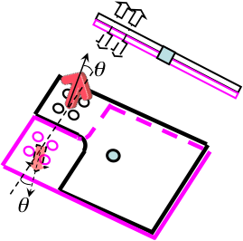 

Figure 5 Mixed loading specimen (tensile + twist mode)

Table Summary of welding conditions and weld nugget sizes

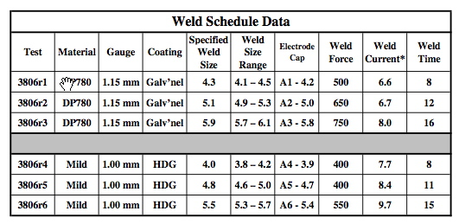

# Microstructure Characterization

Figure 6 shows the appearance of spot welds made under different welding conditions. There are drastic differences in weld microstructure between DP780 welds and DQSK (mild steel) welds. It is also important to point out the solidification shrinkage void at the center of DP780 welds made to the minimum nugget size. The solidification shrinkage induced void was observed on replicate weld samples. Such defect may have contributed to the interfacial failure during quasi-static and impact testing.

Figure 7 shows the microhardness distributions of DP780 and DQSK spot welds. Due to symmetry, only the top half of the spot weld was measured. The overall microhardness distributions of different sized weld of the same steel made with different welding conditions are similar, with slightly higher hardness for the smaller welds. However, DP780 exhibits very different microhardness and strength distribution from the DQSK steel. These differences will need to be considered in the formulation of spot weld element.

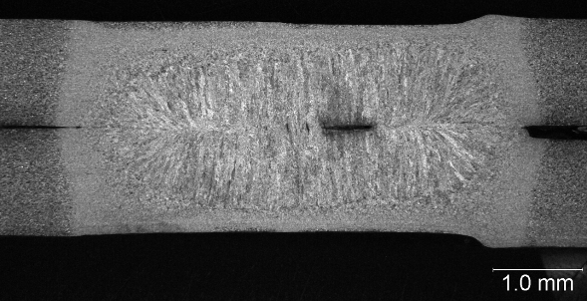 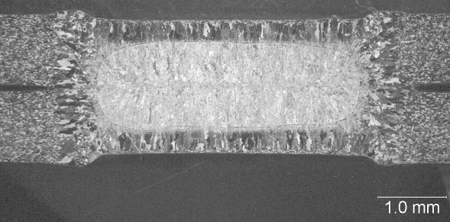

*DP780 minimum nugget size DQSK, minimum nugget size*

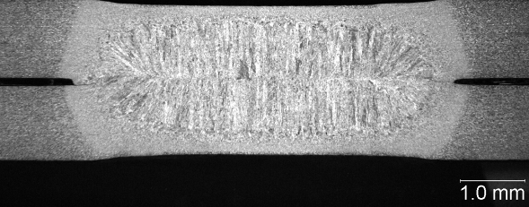 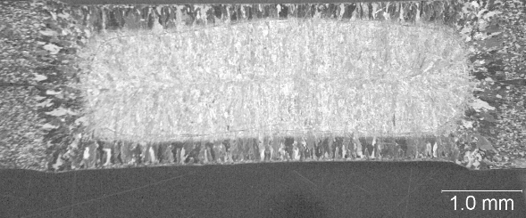

*DP780 medium nugget size DQSK, medium nugget size*

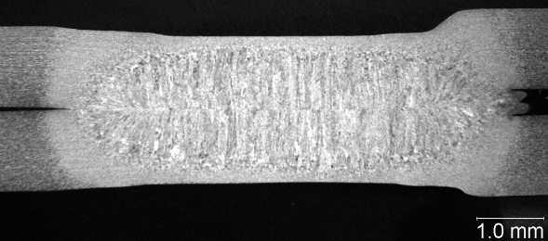 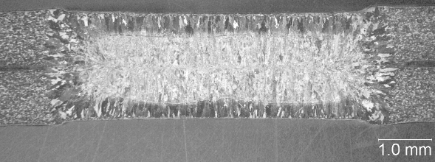

*DP780 maximum nugget size DQSK, maximum nugget size*

Figure Weld nugget appearance of DP780 and DQSK welds. Solidification void was observed in DP780 welds.

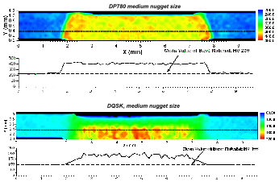

Figure Microhardness mapping of spot welds. Only upper half of the spot weld is measured. The line plots show the hardness variations alone the dashed lines in the hardness mappings.

# Impact and Static Test of Spot Welds

Both dynamic and static testing of the spot welds, in lap-shear, cross-tension, and mixed torsion/tension loading configurations, were performed. The test matrix included the followings:

* Two steels: DQSK, and DP780.
* Three weld nugget sizes: minimum specified, maximum without expulsion, and medium.
* Five loading modes: cross-tension, lap-shear, three combinations of torsion and tension at 0, 30 and 90 degrees.
* Four loading velocities: quasi-static, 2.6m/s (5.8mph), 3.6m/s (8.1mph), and 5.8m/s (12.5mph).

Table 2 summarizes the failure modes observed during the lap-shear and cross-tension test for different loading rates and weld button sizes. For mild steel (DQSK), the failure mode is cleared related to the loading mode. All interfacial failure occurred under shear loading mode. For DP780, interfacial failure is also associated to the shear loading, except for the minimum button size case where solicitation shrinkage void was observed. The weld size also has a pronounced effect - interfacial failure occurred when the weld is at the minimum or medium button size. No interfacial failure was observed at the maximum weld size produced in this study. Increases in loading rate tend to promote the interfacial failure for lap-shear loading condition.

Table Failure modes of spot welds in lap-shear and cross-section tests

 

The effect of weld button size on the failure load of spot welds is provided in Figure 8. The data presented include all the loading rates under lap-shear and cross-tension. Clearly, failure strength is proportional to the weld size. DP780 has much higher failure strength than DQSK. The effect of the loading rate (impact velocity) is shown in Figure 9. For comparison between different steel grades, the failure load is normalized to that under the static loading case. The effect of loading rate (strain rate sensitivity) was clearly observed. Overall, the failure strength generally increases as the strain rate increases. However, the degree of strain rate sensitivity is rather complicated – it appeared to be strongly related to the steel grade and the loading mode.



Figure Effect of weld size on the failure load of spot welds



Figure Percentage change of failure load as function of loading rate (impact speed)

## Experiment data analysis for spot weld model development

In the following, we will examine the measurements from experiments to identify the data that can be used for model development and verification. This process also involves assessment of limitations and uncertainties of the experimental setup with respect to providing consistent boundary conditions and loading for the models. It is found that maximum forces are relatively accurate whereas the displacements are less reliable due to a lack of control in the experiments. Similarly, the impact testing of spot welds reported in literature [65, 78, 101] mainly focuses on measurement of maximum load that joint can sustain. Issues and practices that have been addressed for testing of sheet metal [104, 105] have yet to be applied to spot weld testing so that the entire measurements collected during the test can be used. Test results for spot welds of similar materials (DP780) and configurations were reported in references [7, 106]. In our tests, maximum forces were close to reference [106] and about 40% higher than in reference [7]. The ratio between maximum forces in DP cross-tension and lap shear and specimens (0.5) were lower than usually expected based on experimental and theoretical results for mild steel reported in the literature [72, 73].

Experiment data from the project are accessible via project’s World Wide Web site. The user interface for the experiments database is shown in Figure 10.

The system enables easy evaluation of the effects of loading rate and mode, material, and spot weld diameter. An example of comparison of force-displacement data for cross-tension tests for two different loading speeds is shown in Figure 11.

Energy dissipation during tests as function of displacement can also be calculated and displayed. Measures based on dissipated energy are commonly used for material models. The signal oscillations in impact test can be smoothed by optimal piecewise linear fit algorithm for prescribed tolerance. An example of signal smoothing for an impact test is shown in Figure 12. The piecewise linear fit is calculated from prescribed tolerance of 300 N.

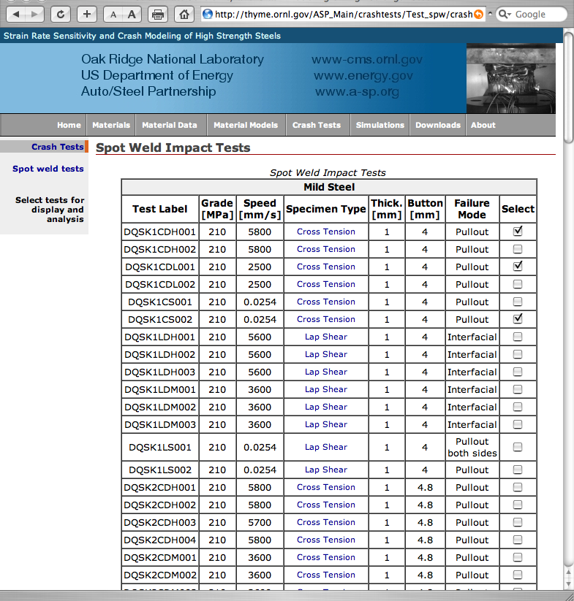

Figure World Wide Web interface to the test data

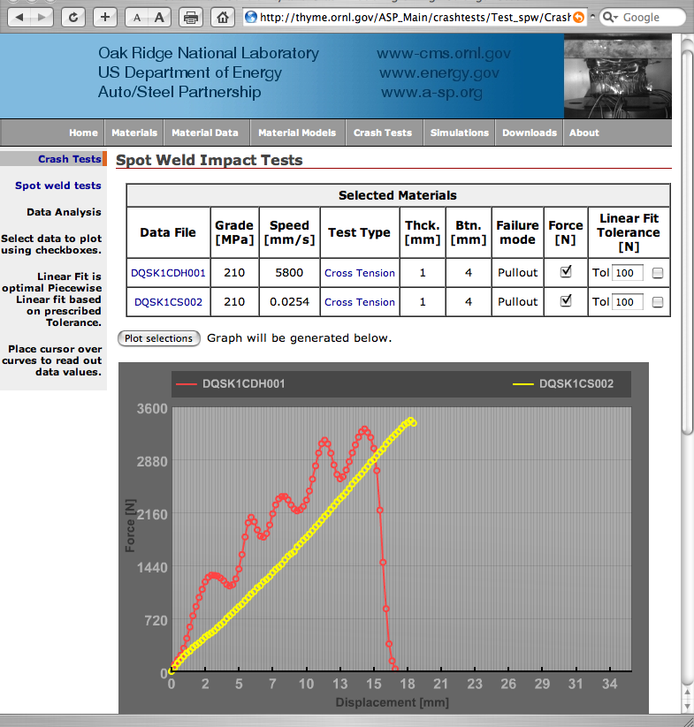

Figure Comparison of static and impact loading for cross-tension test. Material is DQSK steel with spot weld button size 4mm.

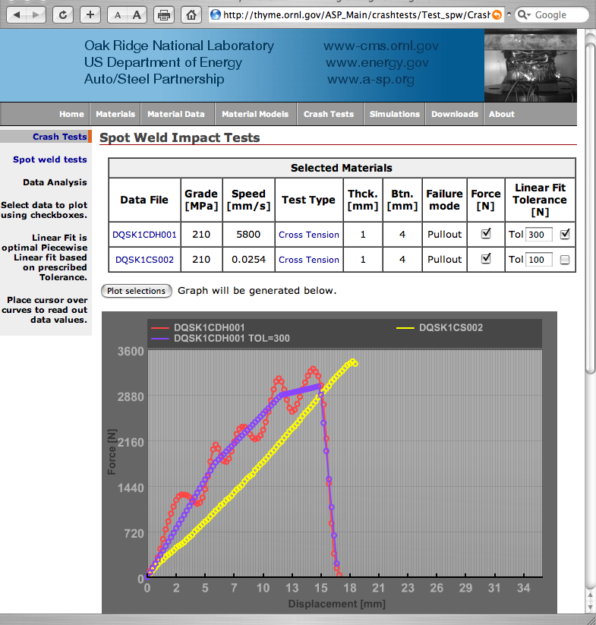

Figure Piecewise linear fit (blue) to the impact test (red)

### Effect of test equipment

Specimens were loaded under quasi-static and impact conditions in hydraulic and drop tower testers, respectively. Force-displacement signals for three lap-shear tests, quasi-static (0.0254 mm/s) and impact (3.6 m/s and 5.6 m/s) are shown in Figure 13.

The maximum force for all tests is relatively close, as expected. However, stiffness of the specimens notably reduces for increasing speed. Such variation is not physically justified because the elastic modulus of steel does not vary in tested rate regime. Therefore, sources of the disparity are most likely displacement measurements and/or slipping in specimen grips. Energy measures that are derived from integration of displacement-force curve will also be unavoidably significantly different. Consequently, only the maximum force in the test can be used for model development and verification. Similar situation can be observed for cross-tension specimens, Figure 14, although because the gripping and plate deflection are orthogonal to the loading, the stiffness of samples across different speeds varies less.

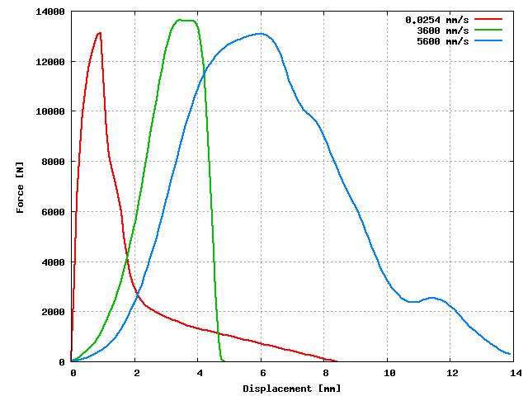

Figure Lap-shear tests under different loading speeds. DP steel. Nugget diameter is 4.3 mm.

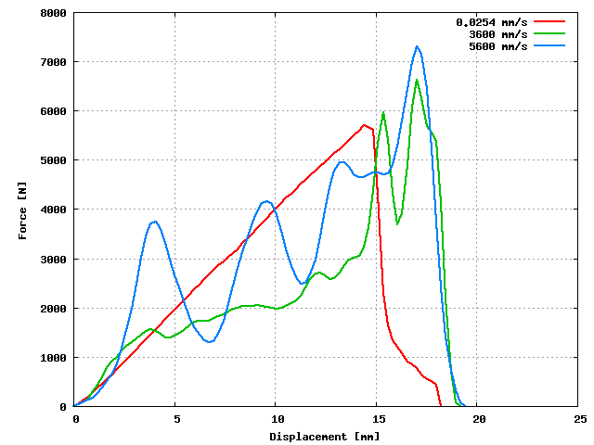

Figure Cross-tension tests under different loading speeds. DP steel. Nugget diameter is 4.3 mm.

### Effect of failure mode

Failure modes of tested specimens were classified into interfacial, pullout and double side pullout modes. This classification has not been reflected in force-displacement measurements and implies a need for further development of the test setup and instrumentation. Figure 15 shows the test result for the three lap-shear tests resulting in pullout, pullout on both sides, and interfacial failure modes, respectively.

The above tests were conducted at similar impact speeds. Force measurement from the double side pullout specimen has significantly larger energy dissipation that does not seem viable with respect to the other two tests. The deformed specimen plates exhibit similar deformation, and confirm this statement. One consistent finding was that when interfacial failure was present, it occurred at lower overall displacement than the pullout in the same configuration.

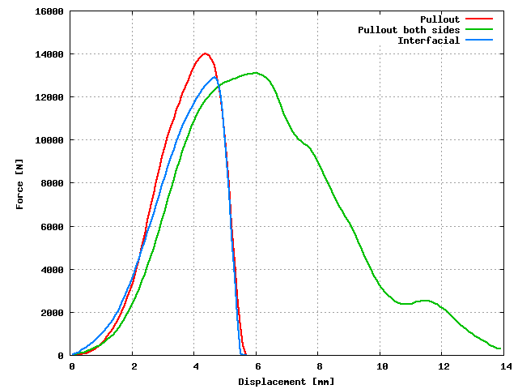

Figure Lap shear tests with different failure modes. DP steel. Nugget diameter is 4.3 mm.

### Loading mode and rate effects in mixed mode specimens

A new mixed mode loading fixture was developed for the project to investigate effects of combined forces and moments outside principal directions that can be achieved by standard cross-tension and lap-shear tests. The fixture generates moments on spot weld by forces on axes that do not pass through the spot weld. The quasi-static tests for the three different loading angles (0, 30, and 90 degrees) as depicted in Figure 5 are shown in Figure 16.

Results clearly show different response for each mode. However, for impact loading, the responses of all mixed-mode configurations are similar. The data for impact test with different loading angle are shown in Figure 17.

One of the apparent uncertanties in the test is the ability of the perforated angle-loading fixture to rotate (Figure 5). This part also has relatively large mass compared to the weld specimen and its inertia may limit its rotation during the test, whereas the rotation may occur more freely in the static test. The large mass of the perforated plate may also induce oscillations in the impact test that can engage specimen plates through contact. These hypotheses still need to be investigated, and will be addressed in possible extension of the project and mixed mode specimen re-design.

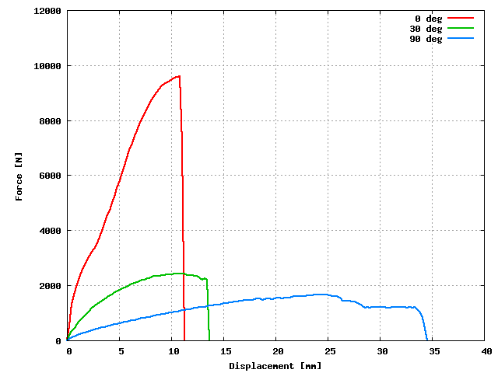

Figure Mixed-mode tests, quasi-static loading. DP steel. Nugget diameter is 5.9 mm.

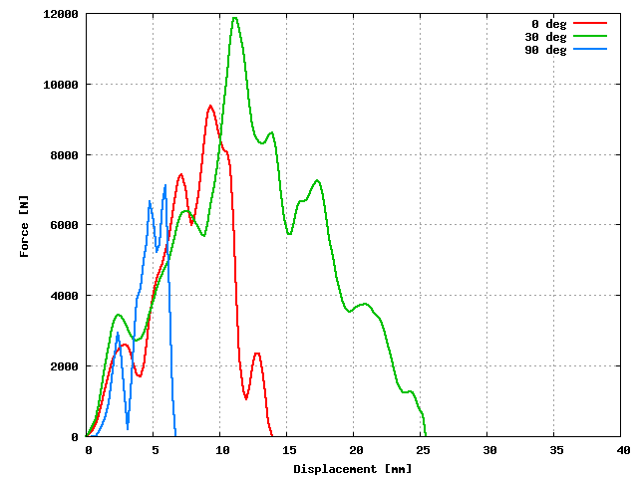

Figure Mixed-mode tests, impact loading. DP steel. Nugget diameter is 5.9 mm.

### Deformation

Loading energy is spot weld specimens primarily dissipated through inelastic deformation of specimen plates. The energy that can be dissipated by a spot weld is relatively small due to its relatively small volume compared to the overall specimen dimensions. In order to characterize the overall deformation, and to develop data for experiment and model validation, we have digitized the tested plates by tracing their longer dimension edges with a pencil and then scanning the resulting curves. These curves include additional deformation due to spring back of the clamped regions but do not account for the deflection in the transverse direction. However, they still provide a good estimate of the total displacement because the above two effects are in the opposite directions. Figure 18 shows the edge scans of the lap shear test for DP steel and 5.9 mm nugget diameter. The impact velocity is 5600 mm/s.

The spot weld specimen from Figure 18 failed in pullout mode. Deflection curve for a specimen failed by the interfacial failure mode is shown in Figure 19. The impact velocity is 5600 mm/s and the nugget diameter is 4.3 mm.

The extent of bending in the specimen failed by interfacial mode is notably smaller compared to the specimen failed in the pull out mode. The difference of energy dissipation for the two tests is also reflected in the force-displacement data (Figure 20).

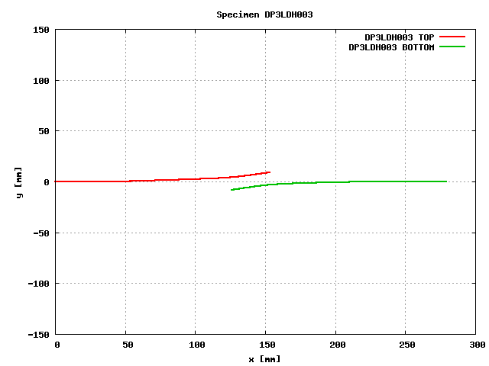

Figure Lap-shear tests deformation. DP steel. Nugget diameter is 5.9 mm.

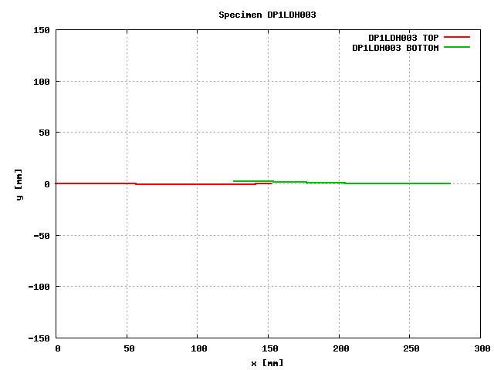

Figure Lap-shear tests deformation. DP steel. Nugget diameter is 4.3 mm.

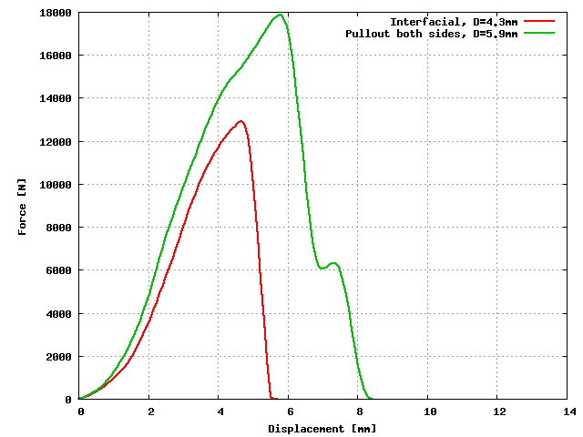

Figure Lap-shear tests force history for two different failure modes. DP steel.

The two tests were loaded with the same impact speed and on the same apparatus so that we can consistently compare the relative difference. The amount of axial and lateral displacements of the lap shear specimens is relatively low compared to the cross-tension and mixed mode specimens. The loading in the cross-tension test is perpendicular to specimen plates and accordingly yields more bending and deflection of the plates. Deflection curves for various cross-tension tests are shown in Figure 21.

Traces from the lower plate deformation were offset vertically in Figure 21 for 20 mm. The clamping regions exhibit deformation that is not consistent across all loading velocities, which may indicate incomplete clamping in the grips which will affect flexibility of the specimens. As a general observation, the deflection in the impact-loaded specimens is larger compared to quasi-static specimens. An example of this difference is shown in Figure 22 where we have zoomed onto the central gage region of the specimen.

Adding maximum deflection of the upper and lower plates provides an independent estimate of the overall test displacement. Results compiled for digitized DQSK steel plates and different spot weld nugget radii are shown in Figure 23.

The compiled deflections for digitized DP steel specimens are shown in Figure 24.

Trend of increasing deflection with increasing nugget radius is consistent for quasi-static tests, whereas for the impact loading such trends cannot be established.

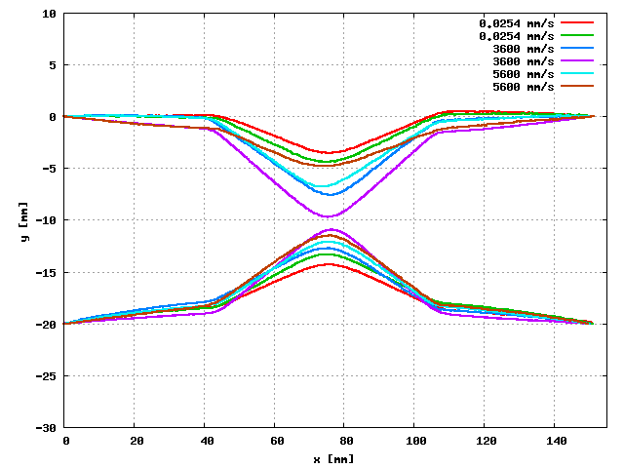

Figure Cross-tension test deformation for different speeds. DP steel. Nugget diameter is 4.3 mm.

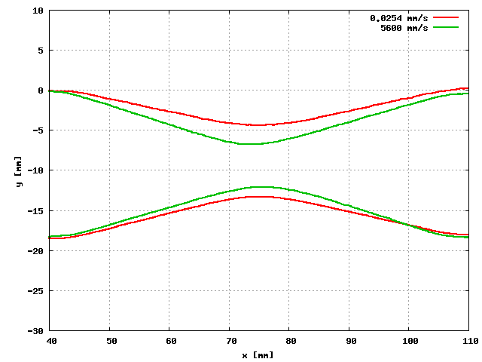

Figure Deformation for cross-tension test under quasi-static and impact loading. DP steel. Nugget diameter is 4.3 mm.

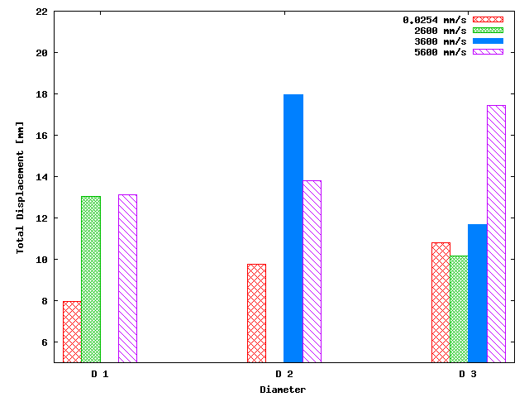

Figure Total displacements for cross-tension test. DQSK steel.

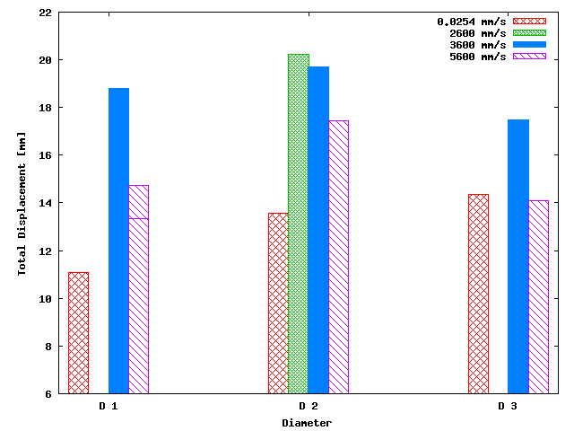

Figure Total displacements for cross-tension test. DP steel.

### Summary

Spot weld experiments conducted in the project provide valuable data for development and validation of the models. A lack of standards, practical difficulties and uncertainties associated with test configurations limit the range and type of data that can be used for model development and validation. The variations and inertia effects in impact tests can skew the measured data and would require modeling of the entire testing apparatus if we were to be able to model the entire duration of the experiments. Therefore, useful data mainly involves maximum force in the test.

# Weld Microstructure and Property Modeling

The SWE requires detailed microstructure and property information in the weld region to properly formulate the constitutive equation. An integrated electrical-thermal-mechanical-metallurgical welding process model for electric resistance spot welding was used in this project, to predict the microstructure and property gradient in the spot weld and the adjacent region. It is based on the early work [16, 107-109] with further refinement of the microstructural model for AHSS.

The RSW process model predicts the weld size, microstructure and residual stresses in a spot weld based on the following user inputs:

* Steel chemistries and base metal microstructure
* Surface coating
* Sheet stack-ups
* Welding conditions (current and electrode force)
* Electrode geometry

A key feature of this integrated weld process model is that it predicts the microstructure evolution based on the calculations of the thermodynamics and kinetics of steel phase transformation processes. There is no need to experimentally measure the continuous cooling transformation (CCT) curves for a given steel, an impossible task for all possible thermal cycles experienced in different locations of the weld and HAZ of a spot weld.

## Modeling Approach

In principle, resistance spot welding utilizes Joule heating (I2R) to produce a molten nugget at the contacting surface of the workpieces. Force is applied before, during and after the application of electric current, to maintain the electric current continuity and to provide the pressure necessary to produce defect-free spot welds. In addition, microstructural changes occur during welding of steels. In this regard, the resistance welding is a multi-physics process encompassing electrical, thermal, mechanical, and metallurgical disciplines. Furthermore, there are strong interactions (coupling) among the electrical, thermal and mechanical aspects of the process that must be included in simulation of the resistance spot welding process, as shown in Figure 25.

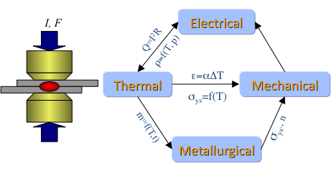

Figure 25 Resistance spot welding – a four-way coupled electrical-thermal-metallurgical-mechanical process

### Electrical-Thermal-Mechanical Interactions/Coupling

The electrical-thermal coupling effect stems from the fact that the electrical properties (bulk resistivity and contact resistance) strongly depend upon the temperature. Changes in the temperature field in the workpiece and the electrodes due to Joule heating result in changes in the Joule heat generation rate that in turn influences the evolution of the temperature field.

The coupling effects of mechanical deformation on the electrical and thermal fields during resistance spot welding process are two-fold. First, the contact area between the electrode and workpiece continuously changes its dimension during the entire welding cycle, as the result of the deformation process. So does the faying interface between the two workpieces. The changes in contact area effectively change the average current density across the contact interfaces, resulting in changes in the Joule heat generation rate at the interfaces. The second coupling effect of the mechanical deformation process is related to the contact resistance at the interfaces. It is well known that the contact resistance decreases as the contact pressure (or the welding force) increases [110]. The contact pressure distribution across a contact interface depends upon the shape of the electrode, temperature, and the base material characteristics. In fact, significant spatial contact pressure variations can exist across the contact interfaces [108]. Therefore, the contact resistance would not be uniform across the interface and change its distribution from one moment to another. This in turn causes pressure-dependent non-uniform Joule heating at the contact interface.

### Thermal-Metallurgical-Mechanical Interactions/Coupling

The deformation process during resistance spot welding is a complex process. It is in part driven by the uneven distribution of temperature by the localized heating and the subsequent uneven cooling of the material. Solidification shrinkage of the molten metal is another driving force.

The solid-state phase transformations in the heat affected zone (HAZ) and the weld metal during welding are additional factors contributing to the deformation process by means of the transformation plasticity and volumetric changes accompanied with the solid-state phase transformation in low alloy steels such as AHSS. In addition, these steels usually exhibit a gradient of microstructural constituents in the weld metal and HAZ, due to the different thermal cycles experience in different regions of the joint (as shown in Figure 6 and Figure 7 for the two steels used in this work). The local microstructural variations, particularly the formation of martensite and bainite, result in local variations of mechanical properties (yield strength, for example) in the weld region that strongly influence the degree of deformation.

### Electric Contact Resistance

The electrical contact resistance has dominant effects on the formation of weld nugget. A general definition of the contact resistance as a function of temperature and contact pressure must be available as input to the simulation model. A phenomenological contact resistance relation [109] was adopted to provide an explicit definition of the contact resistance as a function of temperature and pressure. The phenomenological model was based on the Greenwood equation [111]. This model describes the variation of contact resistance as an explicit function of temperature and pressure. The effects of temperature-dependent yield strength and bulk resistivity on the contact resistance were built in the model. As an example, Figure 26 shows the contact resistance variations for the pressure and temperature ranges relevant to DQSK mild steel.

The calculations show that the contact resistance initially increases with temperature for a given pressure. However, further temperature increases cause the contact resistance to decrease. The competing effects of increasing bulk resistance and decreasing strength with temperature cause this behavior. At low temperatures, the increase in bulk resistance increases the contact resistance. Above a critical temperature range, however, the steel deforms thereby increasing the contact area and decreasing the contact resistance.

ThreeDRes

Figure 26 Steel-steel contact resistance-temperature-pressure diagram of DQSK steel.

### Modeling Microstructure Evolution

Microstructure models for resistance spot welds must be capable of describing the phase transformations during heating, cooling and tempering processes. This includes the phase transformations of austenite to ferrite and ferrite to austenite, the precipitation of carbides in martensite, and the dissolution of carbides and nitrides.

The basic input to the microstructure and mechanical property model are the compositions of the base metal and the weld metal, and the thermal history from the welding heat-flow modeling.

The phase-transformation sequence and final distribution of the microstructural constituent in the weld and HAZ were calculated based on the phase-transformation thermodynamics and kinetics theories, based on the approaches in references [13, 112, 113]. The microstructure calculations consist of a thermodynamic part and a kinetic part. The thermodynamics part determines the materials system equilibria (the critical temperatures for phase transformation such as Ae3, Ae1, and Ac3) and the driving force for transformation due to undercooling, based on the chemistries of the steel. The kinetic part computes the *rate* of phase transformation, based on both the chemical composition and the welding thermal history. The kinetic calculations cover (1) the formation and growth of the austenite grain, (2) the dissolution and coarsening of second particles such as carbides, and (3) the decomposition of austenite into various phases such as ferrite, pearlite, bainite, and martensite.

Once the microstructural constituents are determined, the hardness of each microstructure constituents is calculated using empirically developed equations. The resultant hardness in the HAZ and weld metal is then calculated according to the rule of mixtures by Ion et al. [113]. The material properties such as the yield strength and ultimate strength required for modeling of the stress field are estimated from the hardness data, according to the following equations from [42, 114].

()

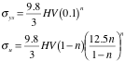

where the units of the yield strength (*ys*) and the ultimate tensile strength (*u*) is MPa. HV is the Vickers hardness number. *n* is the strain hardening coefficient that describes the flow stress in the plastic region:

()



where **  is the true stress, ** the true strain and *K* is a material constants. For the steels studied here, the strain hardening coefficient is taken to be 0.09.

Similar to the calculations of the hardness, the volumetric changes associated with the phase transformation are determined using the rule of mixtures and thermal expansion/contraction data of each microstructural constituent.

The above microstructural modeling algorithms were imbedded into ABAQUS’s analysis procedure by means of user subroutines. The distributions of microstructures and associated material properties during the entire welding cycle are calculated for each element integration point in the FE model. These detailed microstructure gradient data are then used in the stress calculations.

In the parent metal where the microstructure was not affected by the welding thermal cycle, the experimentally determined stress-strain curves are used.

### Incrementally Coupled Modeling Approach

In this work, an incrementally coupled finite element modeling approach is adopted to deal with the above four-way coupling effects. The resistance spot welding process was treated as an electrical-thermal-metallurgical-mechanical contact problem, solved using the finite element method. The interactions between the electrical and thermal fields are solved simultaneously. The thermal history from the electrical-thermal analysis is then used as the input condition for the thermal-metallurgical-mechanical analysis. The interactions between the electrical-thermal analysis and the thermal-metallurgical-mechanical analysis are solved in an incremental fashion. For a given time interval, the thermal-metallurgical-mechanical model determines the contact pressure distribution variation and the apparent contact area change at the contacting interfaces. The updated contact information is then passed into the electrical-thermal model for calculation of electrical and thermal contact behavior. This iterative procedure is applied multiple times during each welding cycle. Through a series of solution convergence analyses, it was determined that 4 to 8 contact pressure updates per welding cycle (4.167x10-3 sec) would be adequate for the cases presented in this study.

The incrementally coupled modeling procedure was implemented in ABAQUS, a commercial general-purpose finite element code, enhanced with a number of user subroutines and drivers. These special user subroutines and drivers were used to simulate the microstructure evolution during welding, to compute the electrical and thermal resistance of the contact interfaces, and to handle the data passing required for the incremental coupling analysis procedure.

## Results

The integrated weld process model was applied to the two steels and different welding conditions used in Phase I. The simulation results compared well with measurement results of the weld microstructure and microhardness distributions in the spot welds. Figure 27 through Figure 30 show examples of the weld process modeling results and comparisons with the experimental hardness measurement results.

The predicted microhardness results were then converted to the yield strength and used in the SWE formulation.

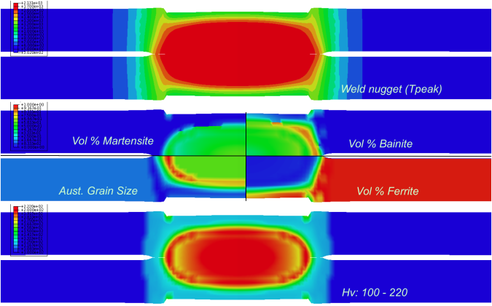

Figure 27. Predicted weld nugget as represented by the peak temperature (top), volume fractions of different phases (middle), and microhardness distribution (bottom) in a DQSK spot weld.

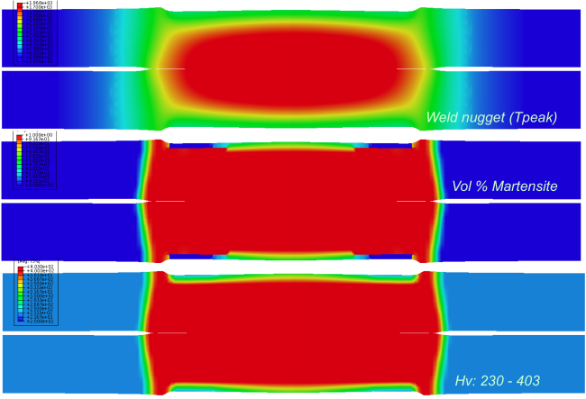

Figure 28. Predicted weld nugget profile as represented by the peak temperature distribution (top), volume fractions of different phases (middle), and microhardness distribution (bottom) in a DP780 spot weld.

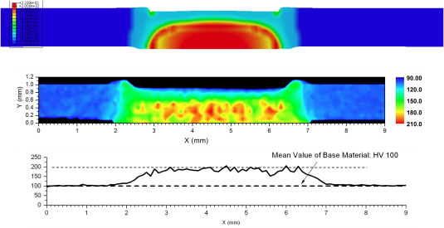

Figure 29. Comparison of microhardness distribution in a DQSK spot weld. Top: prediction, middle: microhardness measurement, bottom: line plot along the middle plan of the steel sheet.

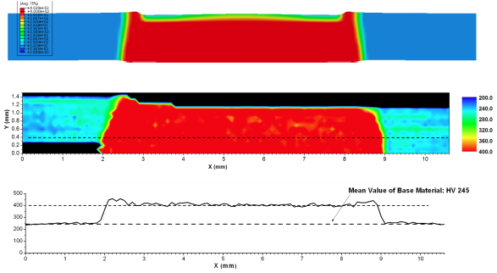

Figure 30. Comparison of microhardness distribution in a DP780 spot weld. Top: prediction, middle: microhardness measurement, bottom: line along the middle plan of the steel sheet.

# Development of SWE

One of the objectives of our research project was to develop and demonstrate an FEM model that would improve on the current modeling techniques for the mechanical response of spot welds in structural problems. Because the spot weld model is to be a part of component-level simulations, its computational performance is very important. While detailed FEM simulations of spot weld mechanics with fine spatial discretization [20, 89, 115] yield accurate results, such strategy cannot be afforded at the structural component scale. Impact simulations based on explicit time integration have to obey stable time increment that is proportional to the smallest characteristic spatial dimension in a computational model. Therefore, the smaller is an element size, the larger is the computational effort required to see the computational simulation to an end. In the current vehicle models with typical shell element span of about 5 mm, deformable spot weld elements have size of the order of plate thickness, and are commonly the candidates for the smallest, controlling time increment. For steel sheet thickness of 1 mm and the steel’s characteristic speed of sound of 5100 m/s, the stable time increment is equal to the time that disturbance traverses a finite element, which is about 0.2 microseconds. This time increment is five times smaller than the current target time step of 1 microsecond. The and deformable spot weld element formulations that are currently in use usually increase it to this target by mass scaling [31].

The proposed formulation of RSW model has a goal of better modeling of stress and strain distributions in the weld zone so that different failure modes can be initiated and evolved depending on the intrinsic measures of material state. It is assumed that with increased spatial FEM resolution [30, 115] it will be feasible to locally reorganize the FEM mesh around the spot weld to create conforming discretizations where the area around the spot weld nugget can be modeled by shell elements and the nugget region itself modeled by solid elements. New solid element formulations are becoming available in the commercial codes [31] that have multiple integration points and better control of locking and hourglass modes, and will eventually replace current reduced element integration formulations [38].

We have also exploited the experimental [21] and modeling observations [20] that the inner region of spot weld nugget is relatively stress-free compared to its periphery. Accordingly, the inner region of the weld can be replaced by computationally inexpensive rigid elements, or equivalently, kinematic constraints. These constraints computationally stabilize solid elements in the outer deformable region of the spot weld and can provide additional mass that can be used for computational speed-up of the region using mass time scaling.

Simplified schemes of two spot weld model configurations used in our study are shown in Figure 31.

The two schemes in Figure 31 depict the cross-section of the spot weld joint, where solid and shell element regions represent the spot weld nugget and sheet metal plates, respectively. The standard 4-node shell element has displacements and rotations of the mid-plane as the degrees of freedom (DOF) of its nodes, whereas, solid elements and solid shells have only nodal displacements as DOF. Coupling of the two element types with different sets of DOF is done by constraining DOF of the shell and (shell) solid nodes such that rotations and displacements of the mid-plane shell nodes are compatible with the displacements of the solid element nodes [116, 117]. From accuracy standpoint, the preferred shell element formulation in LS-DYNA for spot weld simulations [30] is assumed strain, selectively reduced (S/R) shell element [118, 119] [120]. The formulation employs full integration (4 points in shell plane) except for the transverse shear where 1 in-plane integration point is used to avoid shear locking. Computational effort is tripled compared to standard under-integrated shell elements, but this tradeoff has now been generally accepted for practical simulations. Laminate shell theory can be used to relax usual assumption of uniform shear strain through the thickness of the shell to improve approximations of shear distribution close to the nugget, and will be explored in the possible continuation of the project. Through thickness changes of the 4-node shell element can be coupled to solid elements, as well [121]. Solid shell elements provide better estimate of through-thickness shear fields in the HAZ area adjacent to the nugget, but additional concerns of thickness and curvature locking need to be taken into consideration. The DOF of solid and solid-shell elements are compatible, so that the constraint equations translated away from the spot weld nugget and are imposed to shell to solid-shell connection.

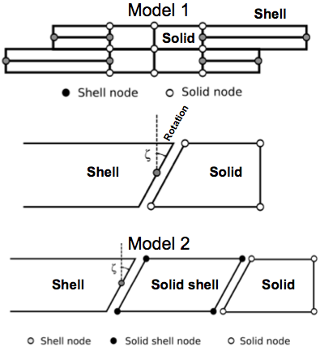

Figure 31 Configuration of the spot weld model in the through-thickness direction. Model 1 has shell elements in the HAZ and the plate whereas Model 2 used 8-node solid shell for the HAZ. The middle figure shows the coupling between the 4-node shell and solid.

## Coupling of solid elements of the nugget with shell elements of the sheet metal

In the following, we outline coupling equations between 4-node shell and solid element following reference [121]. Standard shell element assumptions are: (i) normal to shell’s mid-surface remains straight after deformation, (ii) deformation in the thickness direction is negligible, and (iii) stresses normal to shell mid-plane are disregarded. With these, the equations for shell node with DOF of three displacements and two rotations , with nodal coordinates , and element coordinates in global coordinate system , are:



|  |  |
| --- | --- |
|  | () |

where Nk denote standard bilinear shape functions in the element. Displacements in solid element are function of the translations of the solid nodes, only:

|  |  |
| --- | --- |
|  | () |

Then, standard multi-point constraint equations between the solid element edge (subscript s) and the shell node (subscript k) have the form

|  |  |
| --- | --- |
|  | () |

One problem with this, commonly employed in the FEM codes, approach is that the shell assumption (ii) above is imposed on the solid deformation, which can result in unrealistic stresses, and deformations in the solid element. To relax this constraint, additional two variables are added to the DOF vector that account for elongation of the solid element zone above and below shell mid-plane, respectively. The constraint vector now has the form:



|  |  |
| --- | --- |
|  | () |

and the solid element displacements can be written as:

|  |  |
| --- | --- |
|  | () |

Equation (7) releases shell constraint (ii) from the coupled solid element. As a first step, it is assumed that the effect of shell element thickness change on stress field is negligible. This constraint form will need to be further developed for different spot weld configurations. In a possible extension of the project we will investigate setting the solid element edge as the controlling DOF of the shell-solid connection. Coupling through-thickness deformation of the shell and solid and its effect on stress distribution will also be explored. The research will require modifications of an FEM code that will first be explored in public domain version of impact FEM code DYNA3D. Developed formulation will be implemented as a user element in a commercial FEM code.

## LS-DYNA implementation

The target milestone of the research project was to demonstrate feasibility of the proposed spot weld modeling approach and, if successful, further develop the method into a self-contained FEM formulation in Phase 2. The schematics based on the above constraint conditions of the spot weld assembly with the possible failure zones is shown in Figure 32.

Stress and strain in possible spot weld failure regions or adjacent elements regions can be used to evaluate various fracture criteria that would initiate failure of the joint. In the current research, a simple failure criterion based on the equivalent strain energy to failure was used. The material properties in the weld region were based on the hardness measurements and process modeling simulations. Yield stresses and hardening curves in spot weld zones is estimated by the yield stress of base material multiplied by ratio of the hardness values in the considered zone and the base material. Equivalent strain to failure was reduced accordingly to maintain the same strain energy to failure as the base metal. Failure strain trends reported in the literature for various steels show high degree of variability with respect to process conditions [22, 23, 40, 44, 45], especially for new automotive steels. The above constitutes very simplistic model that will need to be replaced by a more accurate models and criteria [14, 91, 92] in the future, but it was sufficient to illustrate the benefits of the proposed approach. Current version of LS-DYNA does not allow for nodes to be in different constraint sets. In Figure 32, the node of solid element at the juncture of top and bottom plates would have to be in two different constraint sets for each plate. Therefore, it was necessary to insert an extra solid element between the top and bottom solid elements to avoid this conflict. The actual constraint will be implemented in the possible extension of the project in the public domain version of DYNA3D.

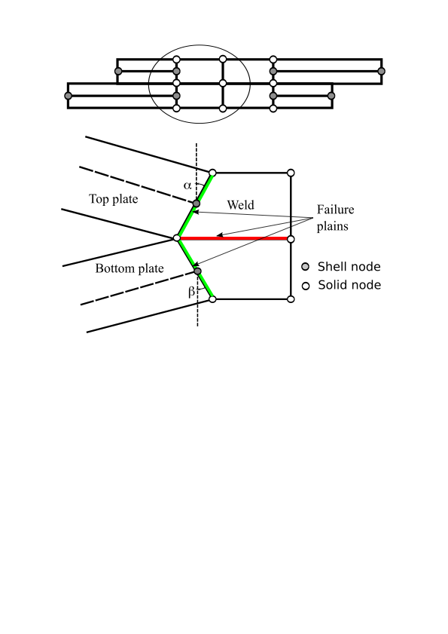

Figure 32 Spot weld model scheme and its failure zones.

## Base material properties

The base material properties of the tested sheets were provided by US Steel Corporation. The measured plastic stress and strain curves for DQSK and DP780 steels are shown in Figure 33 and Figure 34, respectively.

The material data was used as input for LS-DYNA piecewise linear plasticity constitutive material model. The stress-strain curves are represented in the model by optimal piecewise linear segments fitted to experiment data with prescribed error 1% tolerance. As stated above, material stress-strain properties for different spot weld regions are specified as scaled values of the base material by measured hardness ratio.

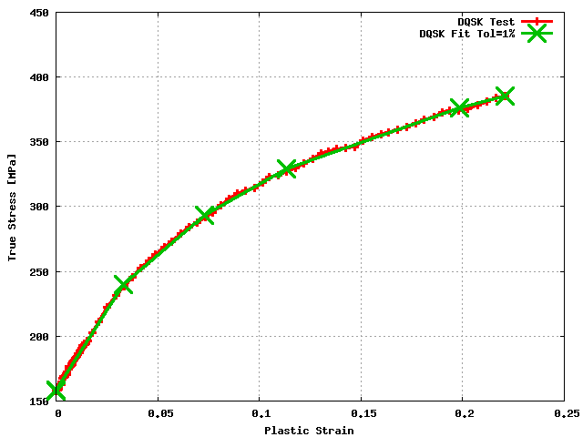

Figure Test and its optimal piecewise fit (1% error tolerance) for DQSK material properties. Cross symbols denote points of linear segments.

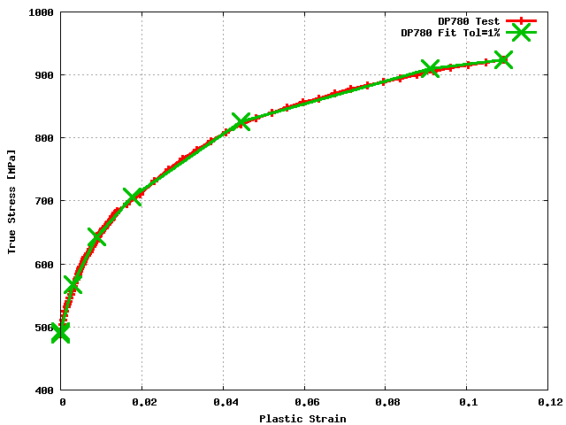

Figure Test and its optimal piecewise fit(1% error tolerance) for DP780 material properties. Cross symbols denote points of linear segments.

## Simulations

Spot weld experiments conducted during the project were simulated by the FEM models with the new spot weld assemblies. As described above, practical limitations and uncertainties from experiments allow for only partial comparison to the models. A good fit to experiments was found without a need to modify the material parameters. There are several different zones in the spot weld model designated as Model 1 in Figure 31. The zones are illustrated in Figure 35:

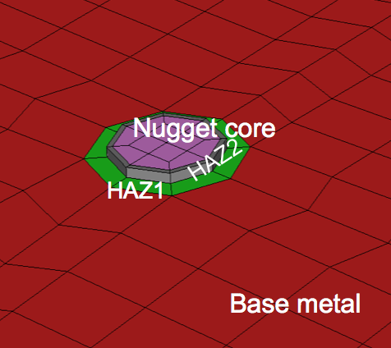

Figure Zones in the spot weld model

Nugget Core and outer nugget area (HAZ2) are modeled by solid elements that are coupled to displacements and rotations of shell elements in HAZ1 region. Material properties assigned to different zones were based on hardness experiments and process models. Base metal and HAZ1 were assumed to have the same properties. HAZ2 and Nugget Core had twice the yield stress and half the strain to failure of the base metal. More detailed distribution have been tested, but we wanted to demonstrate the option of the coarsest and simplest property distribution. In Model 1R variation, Nugget Core elements are assumed to be rigid according to findings in references [20, 21]. Rigid elements can be replaced by constraints that eliminate interior stress calculations and eliminated elements provide some additional mass for mass scaling that is necessary in HAZ1 region. Model 2 from Figure 31 employs solid shells for HAZ1 region and moves away coupling equations between dissimilar elements to the interfaces of HAZ1 and Base metal.

### Lap Shear Simulations

The standard lap shear specimen geometry was simulated with different FEM resolutions. Geometry of very detailed FEM discretization is shown in Figure 36. The clamped regions are cut off in the model and replaced by the clamped boundary conditions on the nodes emerging from the clamps. As such, the model does account for any grip slipping and is expected to exhibit stiffer response than experiments.

Figure 37 shows the simulation side view of the spot weld region of the lap shear test with small nugget diameter, and coarse FEM mesh. The figure shows configurations before and after the failure. The failure of the spot weld in simulation and experiments was along the interface between the two connected sheets.

Comparison of the force-displacement data from simulation and the quasi-static test is shown in Figure 38. The failure of the spot weld in simulation and experiments was along the interface between the two connected sheets.

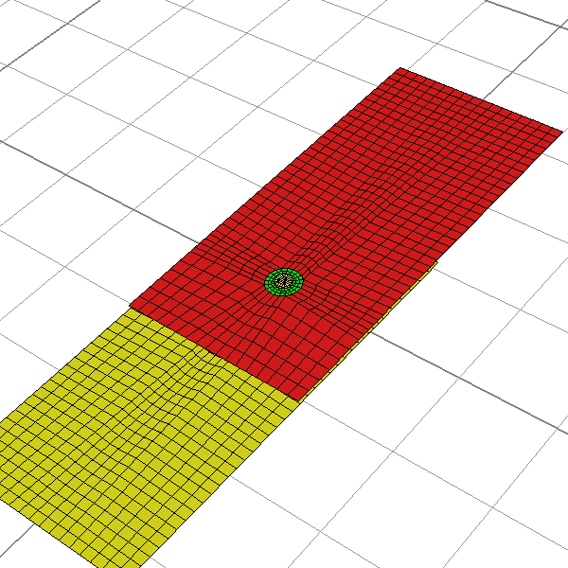

Figure Lap shear specimen model. Detailed FEM mesh

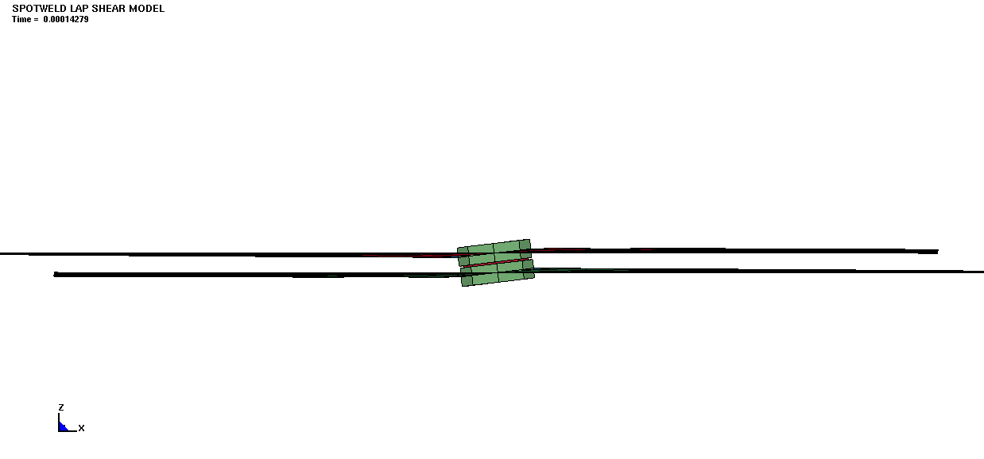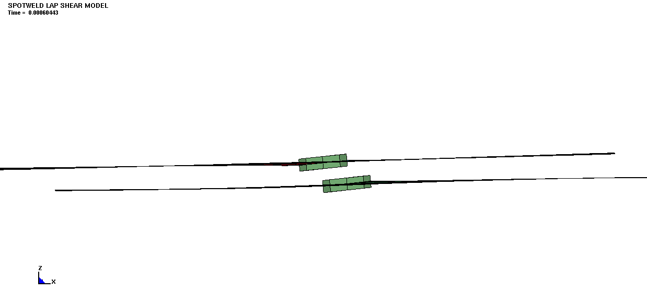

Figure 37 Lap shear test simulation for small spot weld nugget diameter (4.3 mm). DP780 steel.

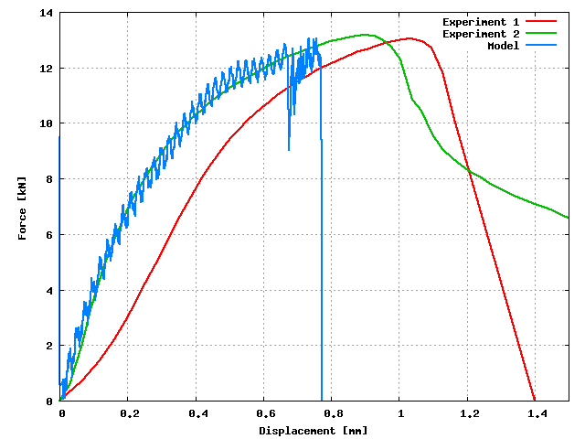

Figure Comparison of the resulting force for experiments and simulations for DP780 steel, small spot weld diameter (4.3 mm).

The resulting force comparison is very close given the experimental scatter and the simplicity of the failure model. Simulation for large spot weld diameter in lap shear test is shown in Figure 39.

The resulting force comparison in Figure 40.is again reasonably close to the resulting force and stiffness of the assembly.

The spot weld model accurately recovers geometry effect [99] based on intrinsic material properties and a very simple failure condition, without a need for accounting of any extrinsic joint properties such as nugget diameter. Simulations with a rigid nugget core (Model 1R) yielded essentially the same results.

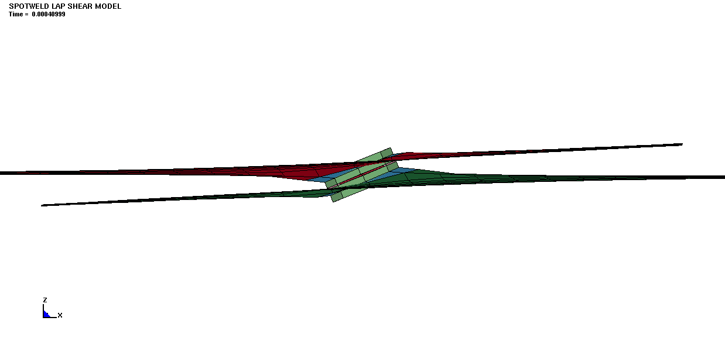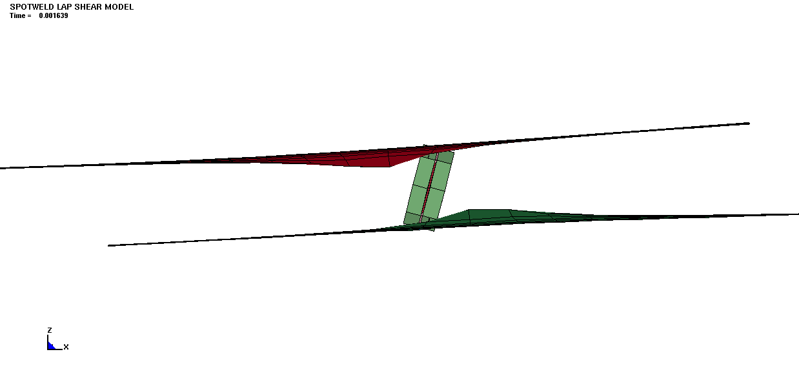

Figure 39 Lap shear test simulation for large spot weld diameter.

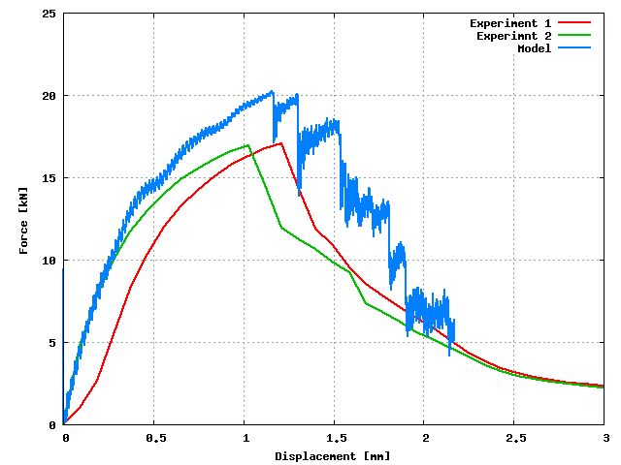

Figure Comparison of the resulting force for experiments and simulations for DP780 steel, large spot weld diameter (5.9 mm).

### Cross-Tension simulations

Mode geometry configuration for the cross-tension test is shown in Figure 41. The plate material in the clamped regions is omitted as for the lap shear mode, and the clamped boundary conditions are imposed on the nodes emerging from the fixture.

Simulation of the cross-tension test of DP780 steel with large nugget diameter (D=5.9mm) is shown in Figure 42

The simulated force-displacement data compared with quasi-static experiments is shown in Figure 43.

The simulation is considerably stiffer than the experiment. When the model is compared with impact experiments, Figure 44, a relatively large scatter of the results can be noted. The origin of this disparity may be in incomplete clamping in experiments, as the post-test specimen analysis showed traces of slipping in the clamps.

The origin of stiffer behavior may also be in the size of the shell elements in the HAZ1 zone. The elements in that zone are responsible for the overall failure. The actual strain localization zone is very small and we need to scale the plastic strain to failure with respect to the size of the finite elements in order to conserve the energy to failure. Normalization procedures [97, 98] and viscous regularization based on strain rate effects [94], can be employed for this purpose. Overall, maximum force in the simulation corresponds very well to the tests.

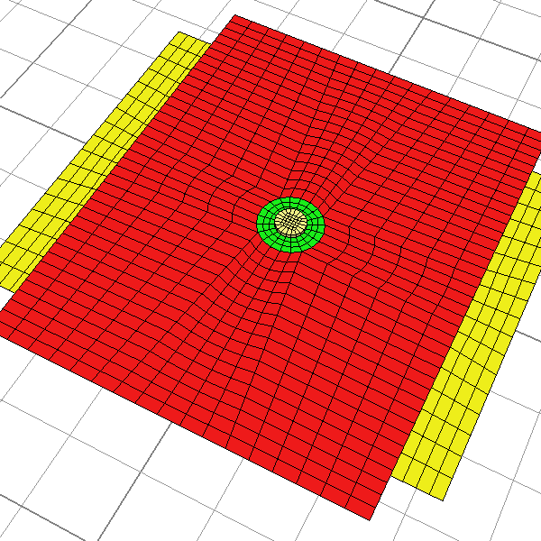

Figure Geometry configuration of the cross-tension specimen. Detailed FEM discretization.

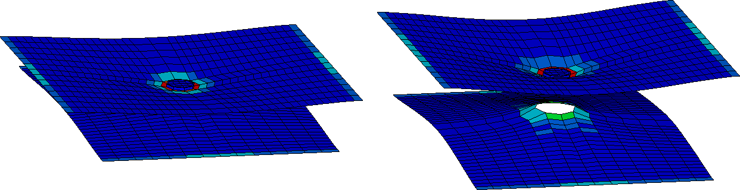



Figure Cross-tension specimen deformation before and after the joint failure. DP780 steel, large spot weld diameter (5.9 mm), coarse mesh.

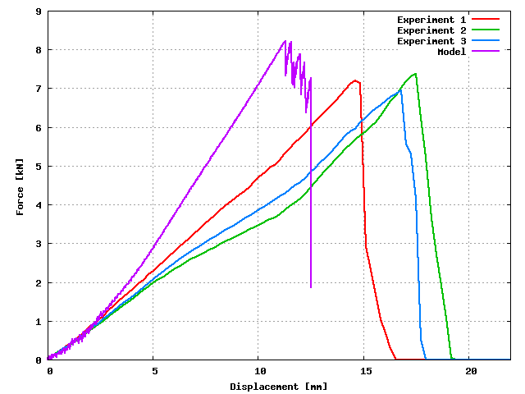

Figure Comparison of the force vs. displacement history from simulations and experiments. DP780 steel, large spot weld diameter (5.9 mm), coarse mesh.

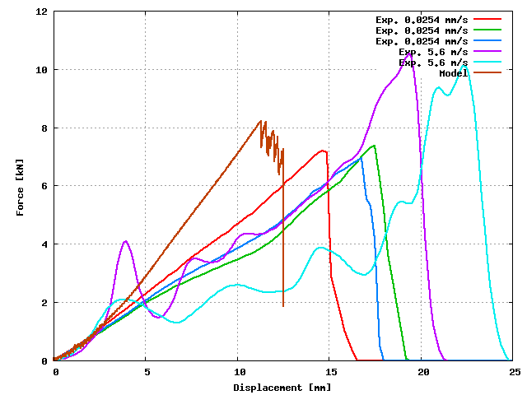

Figure Comparison of the model with experiments for quasi-static and impact tests. DP780 steel, large spot weld diameter (5.9 mm), coarse mesh.

### Mixed Mode simulations

Mixed-mode specimen FEM model for fine discretization is shown in Figure 45. The tab regions that are clamped into the fixture shown in Figure 5, are replaced by the clamped boundary conditions on the edge nodes and displacements in the direction of loading. The implemented boundary conditions, therefore, assume perfectly rigid loading mode with no possibility of rotation of the perforated plate component (Figure 5).

The model is again made structurally stiffer by perfectly rigid boundary conditions. The simulations at this loading angle resulted in interfacial failure, which was in agreement with experiments. The front view of the simulated specimen geometry at failure is shown in Figure 46. Colors denote equivalent plastic strain in elements.

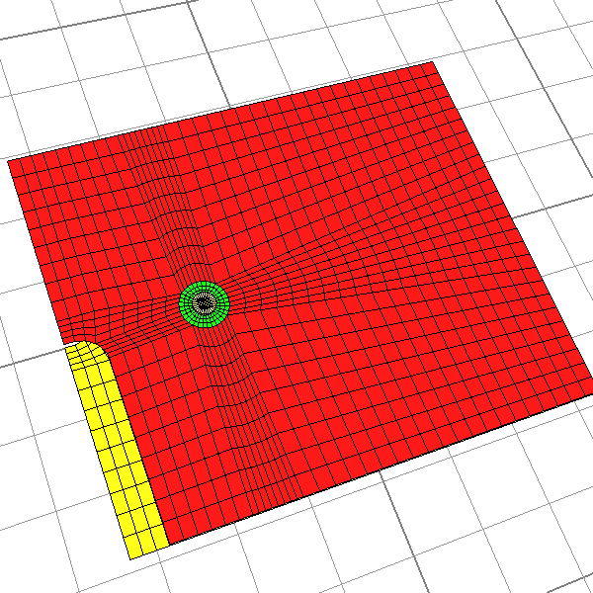

Figure Geometry configuration of the mixed mode specimen. Detailed FEM discretization.

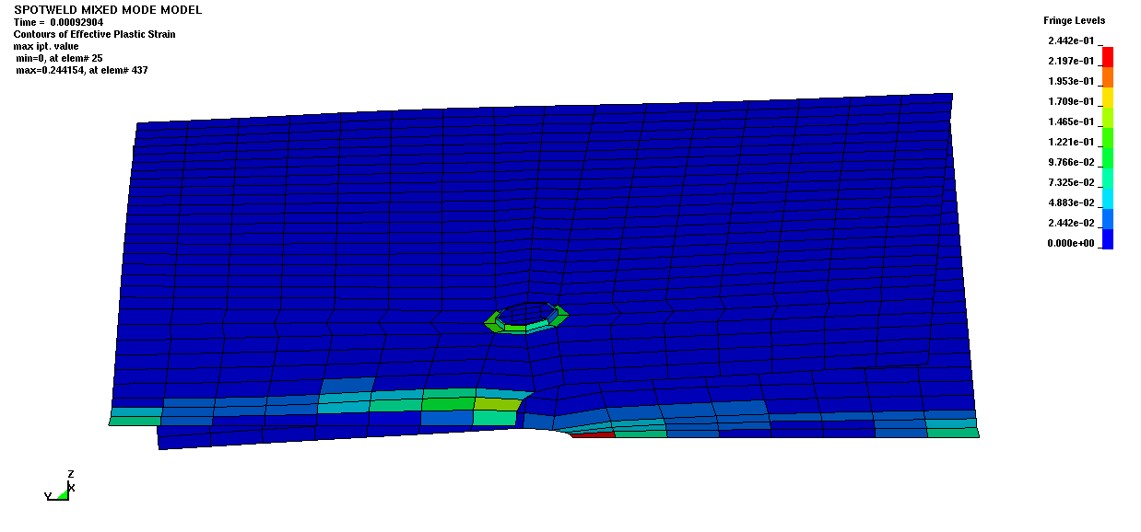

Figure Mixed mode 0 degree test. DP780 steel, spot weld diameter 5.9 mm

The comparison of the force-displacement from a simulation and the tests for the 0 degree loading in Figure 47 shows that the simulations are much stiffer.

However, the maximum forces agree relatively well.

Simulations of 30 degree loading have shown similar trends as the 0 degree tests. The geometry configuration at (interfacial) failure is shown in Figure 48.

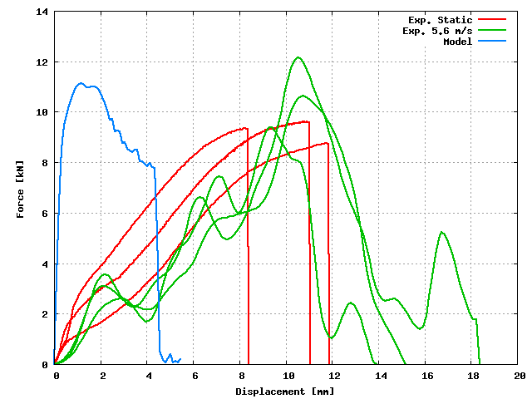

Figure Force displacement data for mixed mode 0 degree test. DP780 steel, spot weld diameter 5.9 mm

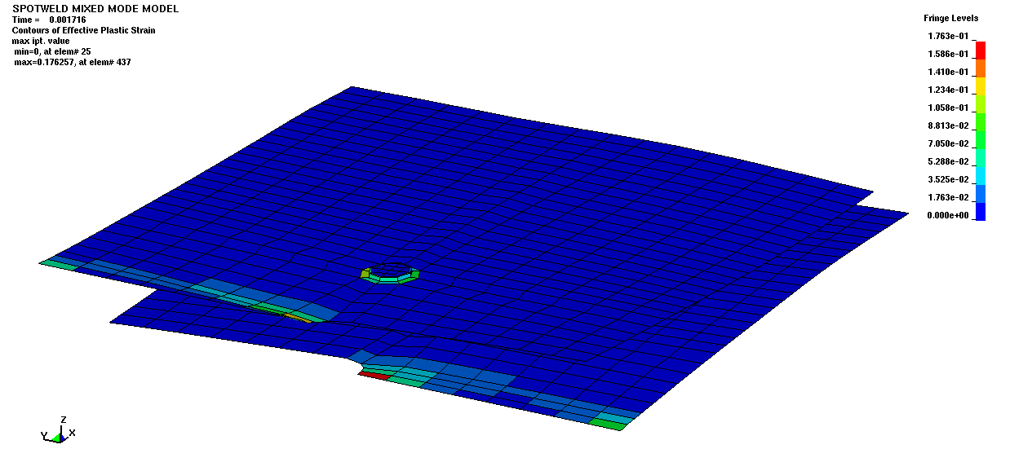

Figure Mixed mode 30 degree test. DP780 steel, spot weld diameter 5.9 mm

All the experiments except one exhibited interfacial failure that was also predicted by the simulation. The experimental scatter of the data was very large as is demonstrated in Figure 49.

Finally, the deformation of the simulated test at 90 degrees loading is shown in Figure 50. The predicted failure mode is pullout as it was observed in all the tests except in one sample.

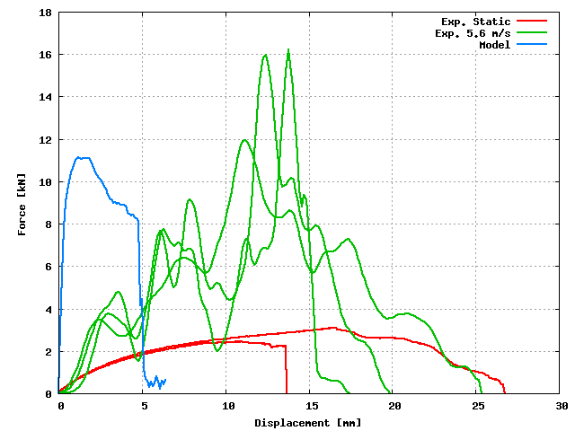

Figure Force displacement data for mixed mode 30 degrees test. DP780 steel, spot weld diameter 5.9 mm

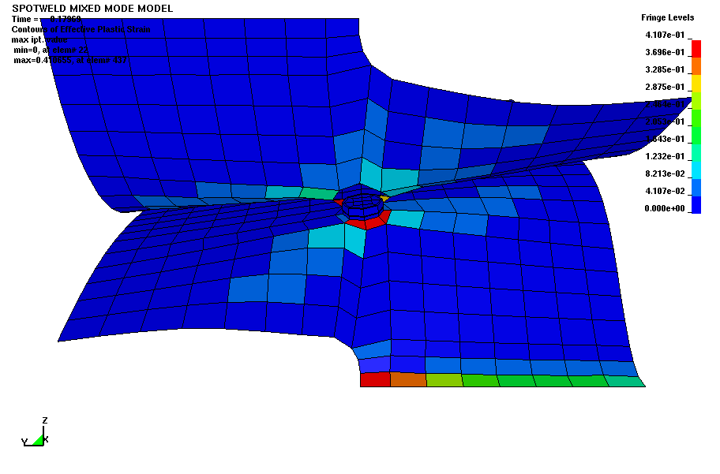

Figure Mixed mode 90 degrees test. DP780 steel, spot weld diameter 5.9 mm

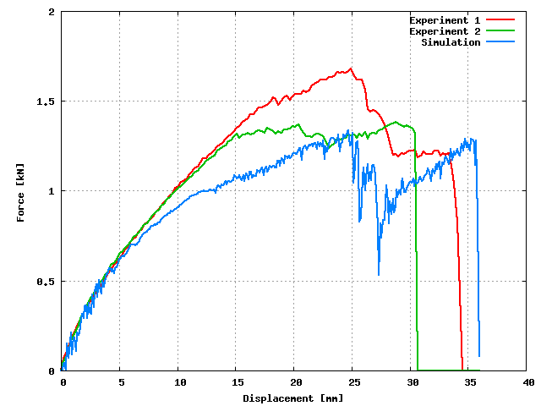

Figure Force displacement data for mixed mode 90 degrees test. DP780 steel, spot weld diameter 5.9 mm

Simulation results are compared with quasi-static tests in Figure 51. The results from dynamics test had enormous scatter and oscillations that made then unusable.

In this case, the stiffness and the maximum force are relatively close. As mentioned above, the considerable variations in the experimental results require further development of test instrumentation and loading control in order to generate data for full model verification.

Overall, the proposed approach is showing a very good agreement with the tests with joint properties that are derived from intrinsic material properties. Better property distribution, directly implemented constraint equations, elimination of limits imposed by current LS-DYNA implementation, stricter models for strain localization and failure, and better element formulation will certainly improve accuracy of the model, but current relatively crude estimates of the properties are yielding very satisfactory results.

# Conclusions

Phase I (concept feasibility) of the project successfully carried out the initial development of the Spot Weld Element (SWE) modeling framework and demonstrated of the effectiveness of such modeling approach. Specifically,

* The initial version of SWE has been developed with the following capabilities:
* Capable of handling weld geometry and weld property gradient, and
* Capable of predicting different fracture modes and fracture load limit experimentally observed in impact tests.
* The initial version of integrated electrical-thermal-mechanical-metallurgical resistance spot weld model has been developed with the following capabilities:
* Capable of predicting weld geometry, microstructure and microhardness distributions, and
* Friendly user input interface for welding parameters, sheet thickness and steel chemistry.
* Baseline spot weld impact test data on DP780 and DQSK steels have been collected and analyzed to characterize the effects of impact speeds and loading modes, and
* A web-based database has been set-up for user-friendly interactive data analysis and retrieval.

# Future Work (Phase II)

The Phase II will be a more comprehensive three-year research and development effort of the SWE modeling framework with the following major milestones:

* Extend the applicability and robustness of Spot Weld Element (SWE) to cover wide range of AHSS grades and spot weld configurations and structural components.
* Extend SWE to weldbond of AHSS,
* Extend SWE to other materials (steel, Al, Mg, and composites) and joining processes (friction bit joining, friction stir joining, arc welding, laser welding) for multi-material body structures,
* Develop weld fracture criteria applicable to different loading and fracture modes, and different combination of materials and joint processes,
* Develop a comprehensive impact testing database, and
* Component level CAE model validation.

The final goals of the project will be the SWE for multiple material configurations, its implementation in FEM crash codes and microstructure-property model for the SWE.

# References

[1] Donders S, Brughmans M, Hermans L, Tzannetakis N. The effect of spot weld failure on dynamic vehicle performance. 2005. p. 16-25.

[2] Applications CoA. Advanced High Strength Steel (AHSS) Application Guidelines. International Iron & Steel Institute; 2005.

[3] Chiang J, Jiang C. Effect of Cooling Rate on Fracture Toughness at the Simulated HAZ of DP600 Steels. SAE Technical Paper. 2004(04M-156).

[4] Feng Z, Chiang J, Jiang C. Effects of Steel Chemistry on the Microstructure and Property of DP600 Weld, MPLUS Program Report. Oak Ridge National Laboratory; 2004.

[5] Kuo M, CHIANG J. Weldability study of resistance spot welds and minimum weld button size methodology development for DP steel. SAE transactions. 2004;113(5):67-77.

[6] Peterson W, Borchelt J. Maximizing cross tension impact properties of spot welds in 1. 5 mm low carbon, dual-phase, and martensitic steels. SAE Transactions: Journal of Materials & Manufacturing. 2000;109:970-981.

[7] Shi S, Westgate S. Resistance spot welding of high-strength steel sheet, (600-1200N/mm2). TWI CRP Report No 767, The Welding InstituteCorporate Research Program Report. 2003;767.

[8] Birch RS, Alves M. Dynamic failure of structural joint systems. Thin-Walled Structures. 2000;36(2):137-154.

[9] White MD, Jones N. Experimental quasi-static axial crushing of top-hat and double-hat thin-walled sections. International Journal of Mechanical Sciences. 1999;41(2):179-208.

[10] White MD, Jones N. Experimental study into the energy absorbing characteristics of top-hat and double-hat sections subjected to dynamic axial crushing. Proceedings of the Institution of Mechanical Engineers Part D-Journal of Automobile Engineering. 1999;213(D3):259-278.

[11] Schneider F, Jones N. Influence of spot-weld failure on crushing of thin-walled structural sections. International Journal of Mechanical Sciences. 2003;45(12):2061-2081.

[12] Tarigopula V, Langseth M, Hopperstad O, Clausen A. Axial crushing of thin-walled high-strength steel sections. International Journal of Impact Engineering. 2006;32(5):847-882.

[13] Babu SS, Goodwin GM, Rohde RJ, Sielen B. Effect of boron on the microstructure of low-carbon steel resistance seam welds. Welding Journal. 1998;77(6):249S-253S.

[14] Wierzbicki T, Bao YB, Lee YW, Bai YL. Calibration and evaluation of seven fracture models. International Journal of Mechanical Sciences. 2005;47(4-5):719-743.

[15] Malcolm S, Nutwell E. Spotweld Failure Prediction using Solid Element Assemblies. 6 th LS-DYNA Users' Conference; 2007.

[16] Feng Z, Babu S, Riemer B, Santella M, GROULD J, Kimchi M. Modeling of resistance spot welds: Process and performance. Welding in the world. 2001;45(11-12):18-24.

[17] Wu S, Saha N. Some Challenges to Crashworthiness Analysis. SAE Technical Paper. 2006(2006-01-0669).

[18] Faruque O, Saha N, Mallela K, Tyan T, Madasamy C, Guimberteau T. Modeling of Spot Weld under Impact Loading and Its Effect on Crash Simulation. SAE Technical Paper. 2006(2006-01-0959).

[19] Du Bois P, Chou C, Fileta B, Khalil T, King A, Mahmood H, Mertz H, Wismans J. Vehicle crashworthiness and occupant protection. Automotive Applications Committee, American Iron and Steel Institute, Southfield, Michigan. 2004.

[20] Deng X, Chen W, Shi G. Three-dimensional finite element analysis of the mechanical behavior of spot welds. Finite Elements in Analysis and Design. 2000;35(1):17-39.

[21] Lei Z, Kang H-T, Reyes G. Full Field Strain Measurement of Resistant Spot Welds Using 3D Image Correlation Systems. Experimental Mechanics. 2008.

[22] Ma C, Chen DL, Bhole SD, Boudreau G, Lee A, Biro E. Microstructure and fracture characteristics of spot-welded DP600 steel. Materials Science and Engineering a-Structural Materials Properties Microstructure and Processing. 2008;485(1-2):334-346.

[23] Milititsky M, Pakalnins E, Jiang C, Thompson A. On Characteristics of Dp600 Resistance Spot Welds. SAE Technical Paper. 2003(2003-01-0520).

[24] Chen W, Deng X. Performance of shell elements in modeling spot-welded joints. Finite Elements in Analysis and Design. 2000;35(1):41-57.

[25] Xu S, Deng X. An evaluation of simplified finite element models for spot-welded joints. Finite Elements in Analysis and Design. 2004;40(9-10):1175-1194.

[26] Palmonella M, Friswell MI, Mottershead JE, Lees AW. Guidelines for the implementation of the CWELD and ACM2 spot weld models in structural dynamics. Finite Elements in Analysis and Design. 2004;41(2):193-210.

[27] Palmonella M, Friswell MI, Mottershead JE, Lees AW. Finite element models of spot welds in structural dynamics: review and updating. Computers & Structures. 2005;83(8-9):648-661.

[28] Dincer S, Cinar A, Kepenek D, Asureciler B, Duran E, Mugan A. A Comparative Study on the Finite Element Models for Spot Welds and Their Verification. SAE Technical Paper. 2006(2006-01-0590).

[29] Schweizerhof K, Schmid W, Klamser H. Improved Simulation of Spotwelds in Comparison to Experiments using LS-DYNA. 18th CAD-FEM Users' Meeting International Congress on FEM Technology. Friedrichshafen (Lake Constance), Germany; 2000.

[30] Mattern S, Schweizerhof K. Wave Propagation in Automotive Structures Induced by Impact Events. In: Nagel WE, Jager W, Resch M, editors. High Performance Computing in Science and Engineering '06: Springer; 2006. p. 459-470.

[31] Hallquist J. LS-DYNA Keyword User's Manual Version 970. Livermore Software Technology Corporation. 2003.

[32] Wang J, Xia Y, Zhou Q, Zhang J. Simulation of Spot Weld Pullout by Modeling Failure Around Nugget. SAE Technical Paper. 2006(2006-01-0532).

[33] Zhang S. A Simplified Spot Weld Model for Finite Element Analysis. SAE Technical Paper. 2004(2004-01-0818).

[34] Heubrandtner T, Rangger G, Scherjau D. Advanced spotweld failure modelling based on Trefftz formulation. 4th LS-DYNA Anwenderforum, Bamberg. 2005.

[35] Seeger F, Feucht M, Frank T, Keding B, Haufe A. An Investigation on Spot Weld Modelling for Crash Simulation with LS-DYNA. 4 th LS-DYNA Forum. Bamberg, Germany; 2004.

[36] Silva I, Magalhaes M. Influence of Spot Weld Modelling on Finite Elements Results for Normal Modes Vibration Modes of a Trimmed Vehicle Body. SAE Technical Paper. 2004(2004-01-3358).

[37] Seeger F, Feucht M, Dumitru G, Graf T. Enhancement of Spot Weld modeling using MAT_100_DAI. 7 th LS-DYNA Forum. Bamberg, Germany; 2008.

[38] Schwer L, Key S, Pucik T, Bindeman L. An assessment of the LS_DYNA Hourglass Formulations via the 3D Patch Test. 5th European LS-DYNA Users Conference. Birmingham, United Kingdom; 2005.

[39] Marya M, Gayden XQ. Development of requirements for resistance spot welding dual-phase (DP600) steels - Part 1 - The causes of interfacial fracture. Welding Journal. 2005;84(11):172S-182S.

[40] Biro E, Lee A. Tensile Properties of Gleeble-Simulated HAZ from Various Dual-Phase Steels. 2008.

[41] Nakayama E, Okamura K, Miyahara M, Yoshida M, Fukui K, Fujimoto H. Prediction of Strength of Spot-Welded Joints By Measurements of Local Mechanical Properties. SAE Technical Paper. 2003(2003-01-2830).

[42] Cahoon JR, Broughton W, Kutzak AR. Determination of Yield Strength from Hardness Measurements. Metallurgical Transactions. 1971;2(7):1979-&.

[43] He MY, Odette GR, Yamamoto T, Klingensmith D. A universal relationship between indentation hardness and flow stress. 2007. p. 556-560.

[44] Zuniga SM, Sheppard SD. Determining the constitutive properties of the heat-affected zone in a resistance spot weld. Modelling and Simulation in Materials Science and Engineering. 1995;3(3):391-416.

[45] Tong W, Tao H, Jiang XQ, Zhang NA, Marya MP, Hector LG, Gayden XHQ. Deformation and fracture of miniature tensile bars with resistance-spot-weld microstructures. Metallurgical and Materials Transactions a-Physical Metallurgy and Materials Science. 2005;36A(10):2651-2669.

[46] Ha JW, Song JH, Huh H, Lim JH, Park SH. Dynamic material properties of the heat-affected zone (haz) in resistance spot welding. 2008. p. 5800-5806.

[47] Zhang SC. Stress intensities at spot welds. International Journal of Fracture. 1997;88(2):167-185.

[48] Zhang SC. Stress intensities derived from stresses around a spot weld. International Journal of Fracture. 1999;99(4):239-257.

[49] Zhang S. Approximate stress intensity factor and notch stress for spot welds. Welding Journal. 2000;79(2):54S-55S.

[50] Zhang S. Approximate stress formulas for a multiaxial spot weld specimen. Welding Journal. 2001;80(8):201S-203S.

[51] Zhang SC. Fracture mechanics solutions to spot welds. International Journal of Fracture. 2001;112(3):247-274.

[52] Zhang S. Recent Developments in Analysis and Testing of Spot Welds. SAE Technical Paper. 2001(2001-01-0432).

[53] Zhang S. A Strain Gauge Method for Spot-Weld Testing. SAE Technical Paper. 2003(2003-01-0977).

[54] Zhang SC. Stress intensity factors for spot welds joining sheets of unequal thickness. International Journal of Fracture. 2003;122(1-2):L119-L124.

[55] Lin P, Pan J, Wang D. Analytical Solution of Mode I Stress Intensity Factor for Spot Welds in Lap-Shear Specimens. SAE Technical Paper. 2006(2006-01-0535).

[56] Lin PC, Wang DA, Pan J. Mode I stress intensity factor solutions for spot welds in lap-shear specimens. International Journal of Solids and Structures. 2007;44(3-4):1013-1037.

[57] Lin P, Pan J. Closed-Form Stress Intensity Factor Solutions for Spot Welds in Various Types of Specimens. SAE Technical Paper. 2008(2008-01-1141).

[58] Lin PC, Pan J. Closed-form structural stress and stress intensity factor solutions for spot welds in commonly used specimens. Engineering Fracture Mechanics. 2008;75(18):5187-5206.

[59] Lin PC, Pan J. Closed-form structural stress and stress intensity factor solutions for spot welds under various types of loading conditions. International Journal of Solids and Structures. 2008;45(14-15):3996-4020.

[60] Sevim I. Effect of hardness to fracture toughness for spot welded steel sheets. Materials & Design. 2006;27(1):21-30.

[61] Wang D, Lin S, Pan J. Local Stress Intensity Factors for Kinked Cracks in Spot Weld Cup Specimens. SAE Technical Paper. 2004(2004-01-0816).

[62] Wang DA, Lin PC, Pan J. Geometric functions of stress intensity factor solutions for spot welds in lap-shear specimens. International Journal of Solids and Structures. 2005;42(24-25):6299-6318.

[63] Wang DA, Lin SH, Pan J. Stress intensity factors for spot welds and associated kinked cracks in cup specimens. International Journal of Fatigue. 2005;27(5):581-598.

[64] Lin P, Pan J. Theoretical Framework for Modeling Spot Welds in Various Types of Specimens. SAE Technical Paper. 2008(2008-01-1136).

[65] Lin S, Pan J, Tyan T, Wu S, Prasad P. Modelling and Testing of Spot Welds Under Dynamic Impact Loading Conditions. SAE Technical Paper. 2002(2002-01-0149).

[66] Lin SH, Pan J, Tyan T, Prasad P. A general failure criterion for spot welds under combined loading conditions. International Journal of Solids and Structures. 2003;40(21):5539-5564.

[67] Lin S, Pan J, Tyan T, Prasad P. A General Failure Criterion for Spot Welds With Consideration of Plastic Anisotropy and Separation Speed. SAE Technical Paper. 2003(2003-01-0611).

[68] Lin SH, Pan J, Wu S, Tyan T. Failure loads of spot weld specimens under impact opening and shear loading conditions. Experimental Mechanics. 2004;44(2):147-157.

[69] Lin P, Lin S, Pan J. Modelling of Plastic Deformation and Failure Near Spot Welds in Lap-Shear Specimens. SAE Technical Paper. 2004(2004-01-0817).

[70] Lin PC, Lin SH, Pan J. Modeling of failure near spot welds in lap-shear specimens based on a plane stress rigid inclusion analysis. Engineering Fracture Mechanics. 2006;73(15):2229-2249.

[71] Pan J, Lin S, Tyan T, Prasad P. Failure Modelling of Spot Welds Under Complex Combined Loading Conditions for Crash Applications. SAE Technical Paper. 2002(2002-01-2032).

[72] Chao YJ. Failure mode of spot welds: interfacial versus pullout. Science and Technology of Welding and Joining. 2003;8(2):133-137.

[73] Chao YJ. Ultimate strength and failure mechanism of resistance spot weld subjected to tensile, shear, or combined tensile/shear loads. Journal of Engineering Materials and Technology-Transactions of the Asme. 2003;125(2):125-132.

[74] Yoda S, Kumagai K, Yoshikawa M, Tsuji M. Development of a Method to Predict the Rupture of Spot Welds in Vehicle Crash Analysis. SAE Technical Paper. 2006(2006-01-0533).

[75] Langrand B, Combescure A. Non-linear and failure behaviour of spotwelds: a "global" finite element and experiments in pure and mixed modes I/II. International Journal of Solids and Structures. 2004;41(24-25):6631-6646.

[76] Ishiwatari A, Yoshitake A, Hira T. Fracture Criteria of Spot Welded Joint for Car Crash FE Analysis. SAE Technical Paper. 2006(2006-01-0534).

[77] Barkey ME, Kang H. Testing of spot welded coupons in combined tension and shear. Experimental Techniques. 1999;23(5):20-22.

[78] Gunawan F, Homma H, Adhikari B. Nugget Strength of Spot Weld under Shear Impact Load. Journal of Solid Mechanics and Materials Engineering. 2008;2(8):1136-1145.

[79] Madasamy C, Guimberteau T, Tyan T, Faruque O. An Investigation of Spot-Welded Steel Connections Using a DOE Approach. SAE Technical Paper. 2003(2003-01-0612).

[80] Madasamy C, Tyan T, Faruque O. Methodology for Testing of Spot-Welded Steel Connections Under Static and Impact Loadings. SAE Technical Paper. 2003(2003-01-0608).

[81] Madasamy C, Guimberteau T, Tyan T, Faruque O. Determination of Spot Weld Modelling Parameters From Test Data for Finite Element Crash Simulation. SAE Technical Paper. 2004(2004-01-0692).

[82] Madasamy C, Tyan T, Faruque O. Finite Element Modelling of Spot Weld Connections in Crash Applications. SAE Technical Paper. 2004(2004-01-0691).

[83] Pinho ST, Iannucci L, Robinson P. Formulation and implementation of decohesion elements in an explicit finite element code. Composites Part a-Applied Science and Manufacturing. 2006;37(5):778-789.

[84] Song JH, Wang HW, Belytschko T. A comparative study on finite element methods for dynamic fracture. 2008. p. 239-250.

[85] Cavalli MN, Thouless MD, Yang QD. Cohesive-zone modeling of the deformation and fracture of weld-bonded joints. Welding Journal. 2004;83(4):133S-139S.

[86] Cavalli MN, Thouless MD, Yang QD. Cohesive-zone modelling of the deformation and fracture of spot-welded joints. Fatigue & Fracture of Engineering Materials & Structures. 2005;28(10):861-874.

[87] Zhou B, Thouless MD, Ward SM. Determining mode-I cohesive parameters for nugget fracture in ultrasonic spot welds. International Journal of Fracture. 2005;136(1-4):309-326.

[88] Zhou B, Thouless MD, Ward SM. Predicting the failure of ultrasonic spot welds by pull-out from sheet metal. International Journal of Solids and Structures. 2006;43(25-26):7482-7500.

[89] Lamouroux E, Coutellier D, Doelle N, Kuemmerlen P. Detailed model of spot-welded joints to simulate the failure of car assemblies. International Journal on Interactive Design and Manufacturing. 2007;1(1):33-40.

[90] Pickett AK, Pyttel T, Payen F, Lauro F, Petrinic N, Werner H, Christlein J. Failure prediction for advanced crashworthiness of transportation vehicles. 2004. p. 853-872.

[91] Du Bois P, Kolling S, Feucht M, Haufe A. A Comparative Review of Damage and Failure Models and a Tabulated Generalization. 6 th LS-DYNA Users' Conference; 2007.

[92] Bao YB, Wierzbicki T. On fracture locus in the equivalent strain and stress triaxiality space. International Journal of Mechanical Sciences. 2004;46(1):81-98.

[93] Song JH, Belytschko T. Cracking node method for dynamic fracture with finite elements. International Journal for Numerical Methods in Engineering. 2009;77(3):360-385.

[94] Needleman A. Material rate dependence and mesh sensitivity in localization problems. Comp Methods Appl Mech Eng. 1988;67(1):69-85.

[95] Needleman A. On the competition between failure and instability in progressively softening solids. Journal of Applied Mechanics-Transactions of the Asme. 1991;58(1):294-296.

[96] Belytschko T, Mish K. Computability in non-linear solid mechanics. Int J Numer Meth Eng. 2001;52:3-21.

[97] Crisfield M. Non-linear finite element analysis of solids and structures. John Wiley & Sons Inc, 1991.

[98] Bazant Z, Planas J. Fracture and size effect in concrete and other quasibrittle materials. CRC Press, 1998.

[99] Kumagai K, Shirooka M, Ohachi J, Ogawa T. Rupture Modeling of Spot Welds Suitable for Crash FE Analysis in Vehicle Development Process. Transactions-Society of Automotive Engineers of Japan. 2007;38(6):283.

[100] Haggag F, Bell G. Measurement of yield strength and flow properties in spot welds and their HAZs at various strain rates. International Trends in Welding Sciences and Technology:637-642.

[101] Bayraktar E, Kaplan D, Grumbach M. Application of impact tensile testing to spot welded sheets. Journal of Materials Processing Technology. 2004;153:80-86.

[102] Flanagan DP, Belytschko T. A Uniform Strain Hexahedron and Quadrilateral with Orthogonal Hourglass Control. International Journal for Numerical Methods in Engineering. 1981;17(5):679-706.

[103] Belytschko T, Bindeman LP. Assumed Strain Stabilization of the 8 Node Hexahedral Element. Computer Methods in Applied Mechanics and Engineering. 1993;105(2):225-260.

[104] Borsutzki M, Cornette D, Kuriyama Y, Uenishi A, Yan B, Opbroek E. Recommendations for Dynamic Tensile Testing of Sheet Steels. Intern Iron and Steel Institute. 2005.

[105] Yan B, Kuriyama Y, Uenishi A, Cornette D, Borsutzki M, Wong C. Recommended Practice for Dynamic Testing for Sheet Steels-Development and Round Robin Tests. 2006.

[106] Futamura Y, Miura M. Characteristics of 780MPa and 980MPa Grade Hot-dip Galvannealed Steel Sheets. Kobe Steel Engineering Reports. 2007;57(2).

[107] Feng Z, Wang X, David S, Sklad P. Modeling of residual stresses and property distributions in friction stir welds of aluminum alloy 6061-T6. 2004.

[108] Feng Z, Babu S, Santella M, Riemer B, Gould J. An incrementally coupled electrical-thermal-mechanical model for resistance spot welding. 1998. p. 1-5.

[109] Yang YP, Babu SS, Orth F, Peterson W. Integrated computational model to predict mechanical behaviour of spot weld. Science and Technology of Welding and Joining. 2008;13(3):232-239.

[110] Vogler M, Sheppard S. Electrical contact resistance under high loads and elevated-temperatures. Welding Journal. 1993;72(6):S231-S238.

[111] Greenwood J. Constriction resistance and real area of contact. British Journal of Applied Physics. 1966;17(12):1621-&.

[112] Ashby MF, Easterling KE. A 1st report on diagrams for grain-growth in welds. Acta Metallurgica. 1982;30(11):1969-1978.

[113] Ion JC, Easterling KE, Ashby MF. A 2nd report on diagrams of microstructure and hardness for heat-affected zones in welds. Acta Metallurgica. 1984;32(11):1949-&.

[114] Cohron J, Santella M, Babu S. Oak Ridge National Laboratory; 1998.

[115] Seeger F, Michel G, Blanquet M. Investigation of Spot Weld Behavior Using Detailed Modeling Technique. 7 th LS-DYNA Forum. Bamberg, Germany; 2008.

[116] McCune RW, Armstrong CG, Robinson DJ. Mixed-dimensional coupling in finite element models. International Journal for Numerical Methods in Engineering. 2000;49(6):725-750.

[117] Shim KW, Monaghan DJ, Armstrong CG. Mixed dimensional coupling in finite element stress analysis. 2002. p. 241-252.

[118] Hallquist J. LS-DYNA Theory Manual. Livermore Software Technology Corporation; 2006.

[119] Bathe KJ, Dvorkin EN. A Formulation of General Shell Elements - The Use of Mixed Interpolation of Tensorial Components. International Journal for Numerical Methods in Engineering. 1986;22(3):697-722.

[120] Dvorkin E, Bathe K. A continuum mechanics based four-node shell element for general nonlinear analysis. Engineering Computations. 1984;1(1):77-88.

[121] Wang J, Lou Z, Min X, Zou J. DOF expanding method for connecting solid and shell element. Communications in Numerical Methods in Engineering. 1996;12(6):321-330.